Task on Jenkins -03
Create one Jenkins job using the below code and create three stages.
- stage1: Git clone to download the source code.
- Source Code: https://github.com/betawins/VProfile-1.git
Go to Jenkins --- create a build
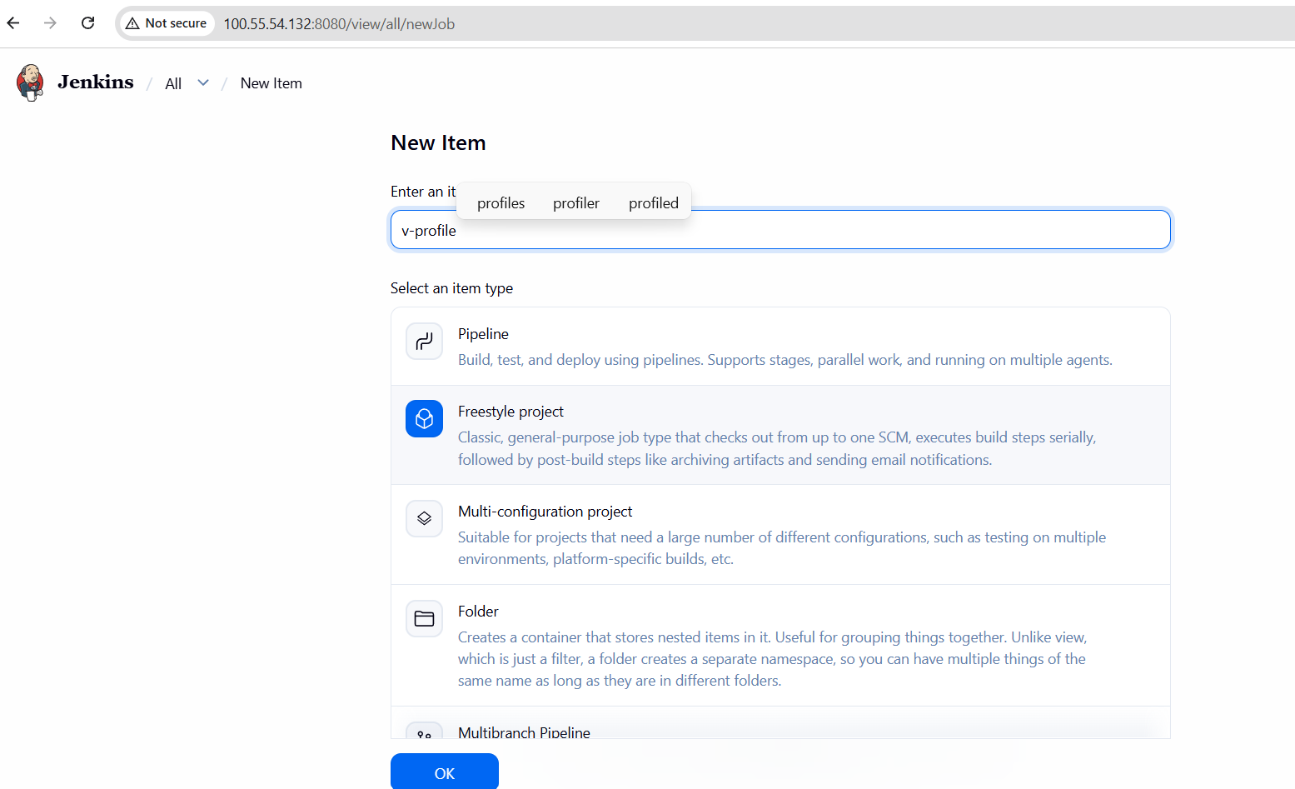
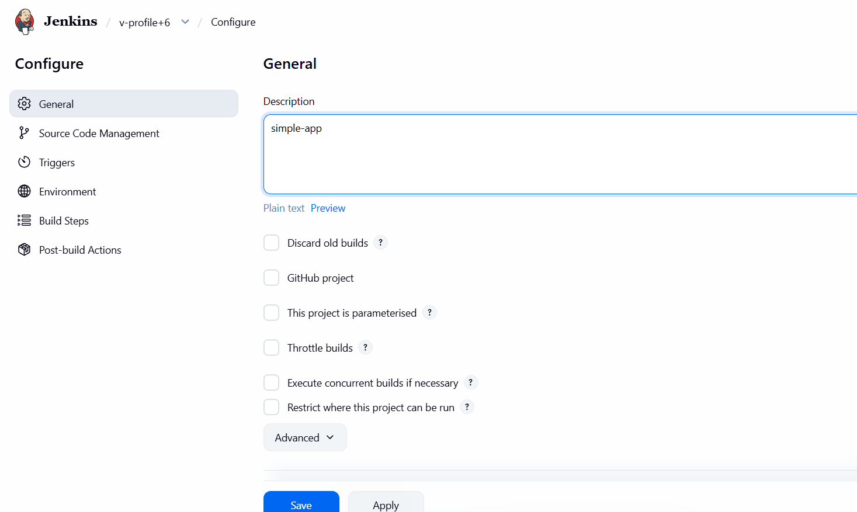
Choose git and provide the url that we want to clone
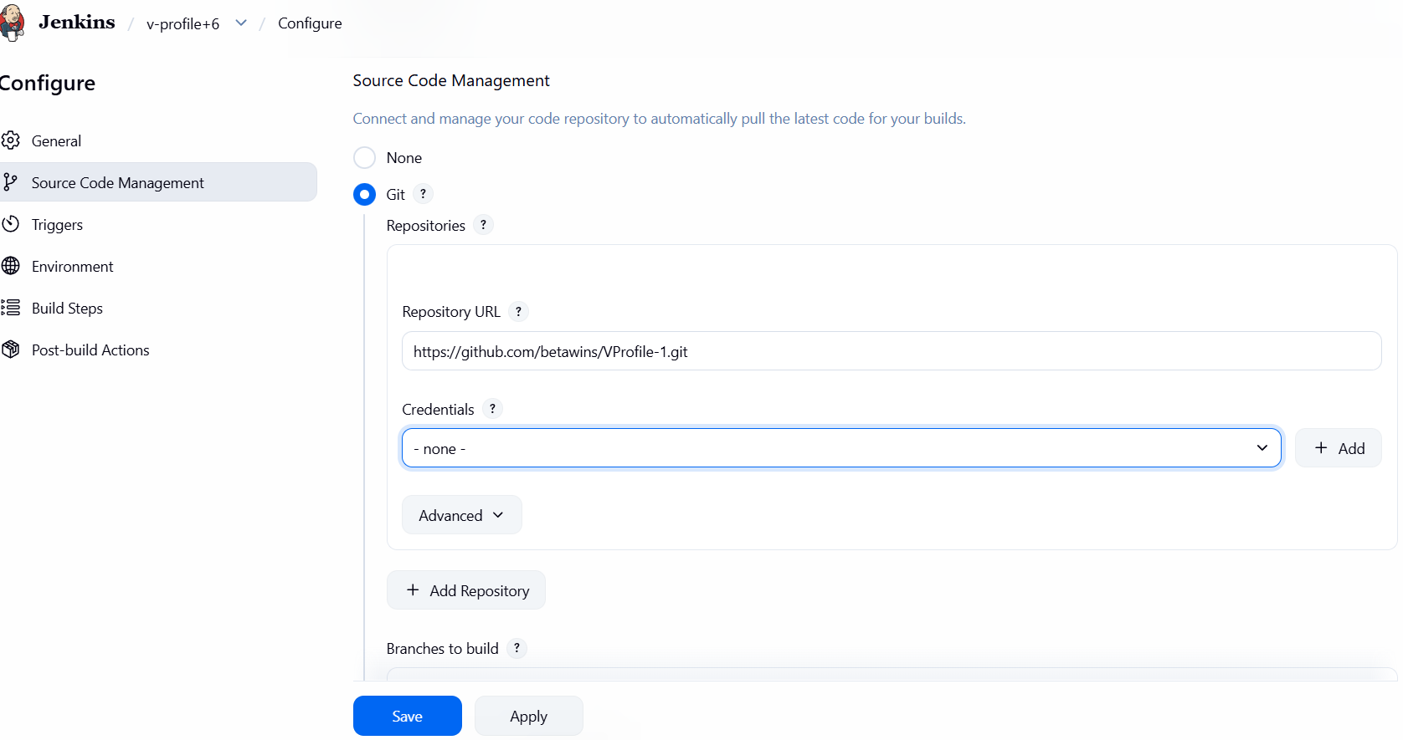
Click on build
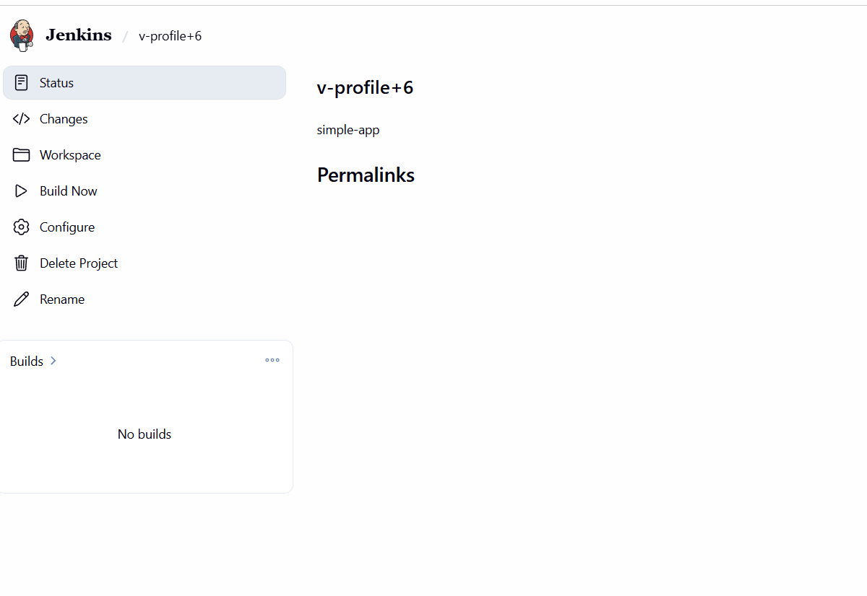
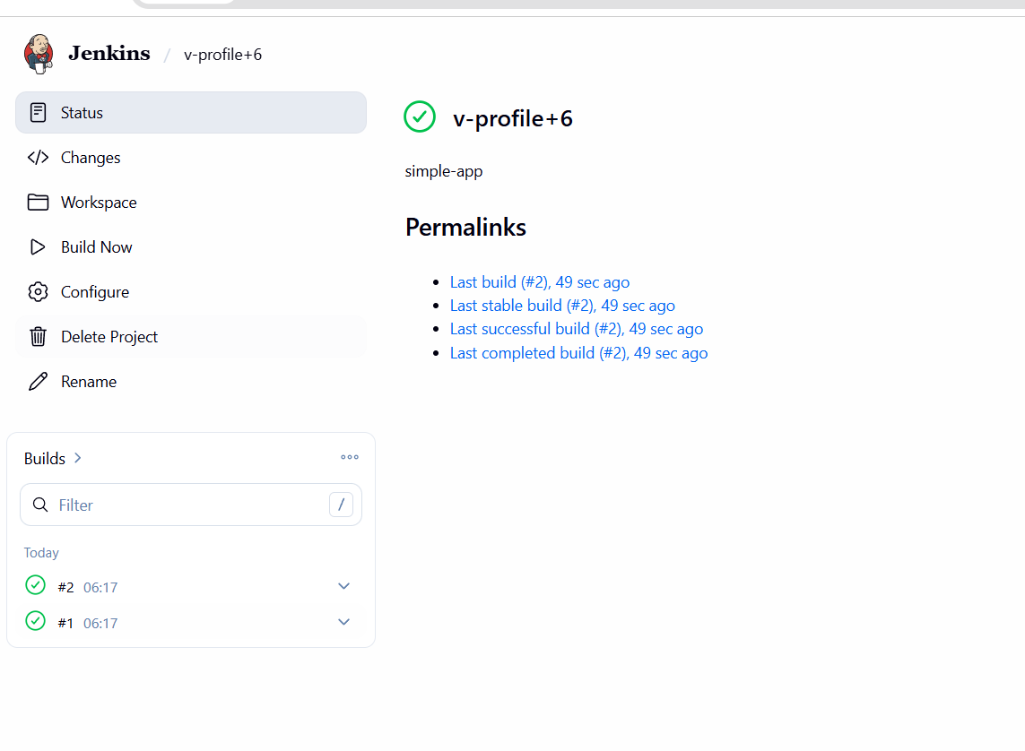
Successfully cloned
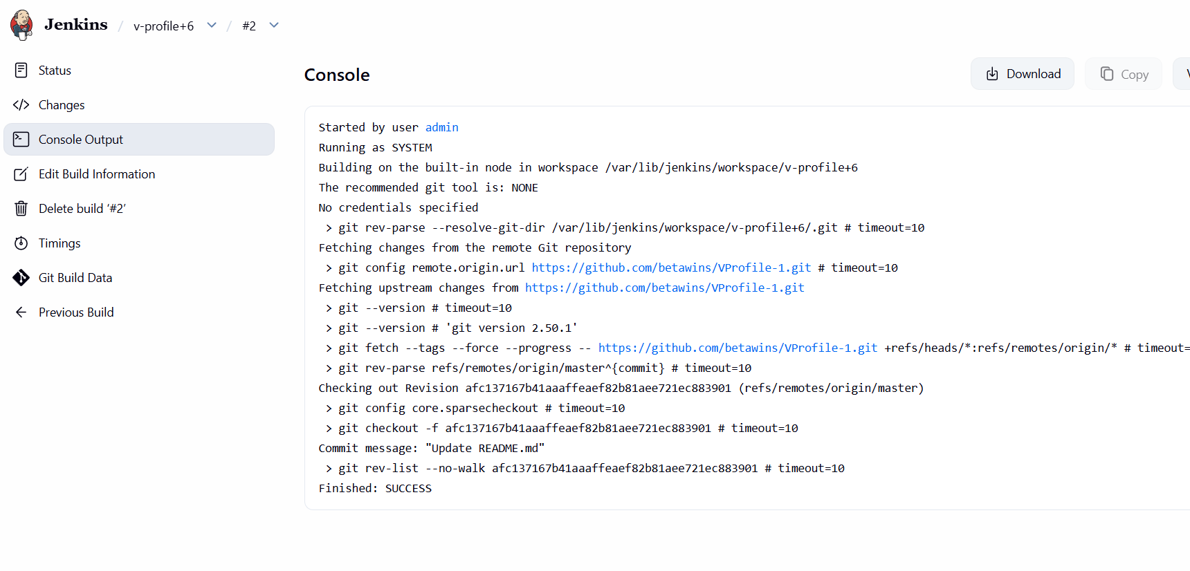
Here when we try to check in server to see the repository. It is cloned successfully
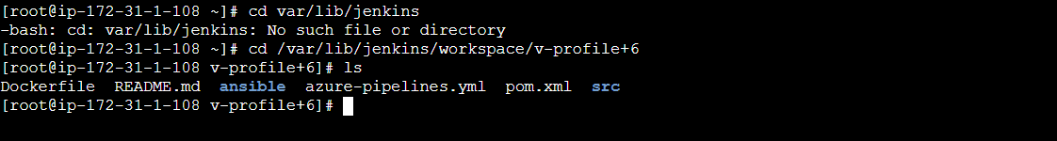

- stage2: Sonarqube Integration to check the quality of code.
- To integrate sonarqube, we need to have sonarqube server
- SonarQube : It will check the quality of code
- Lets set up SonarQube server
- 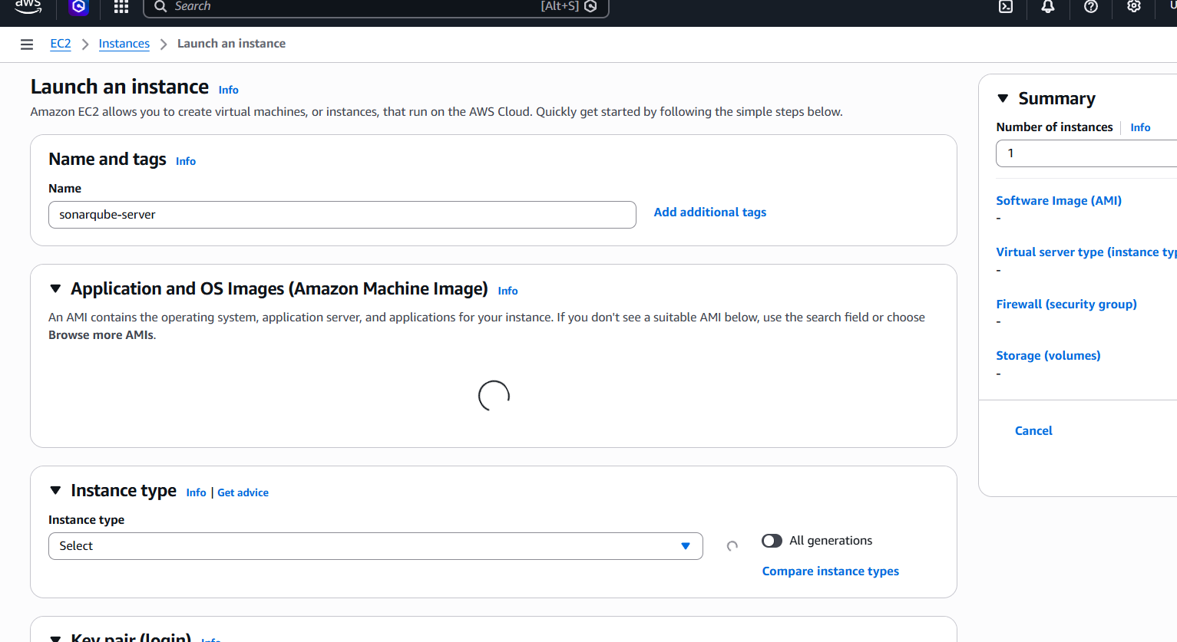
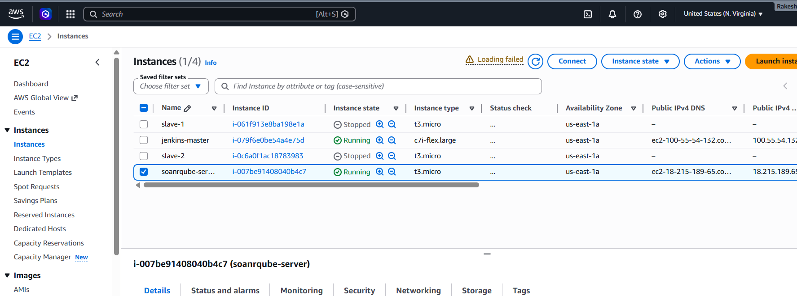
Prerequisites for SonarQube Server
--EC2 instance : c7i-flex-large
-- Storage: At least 20 GB
-- Java: Version 1.8 installed
--MySQL 5.7: Used to store generated reports
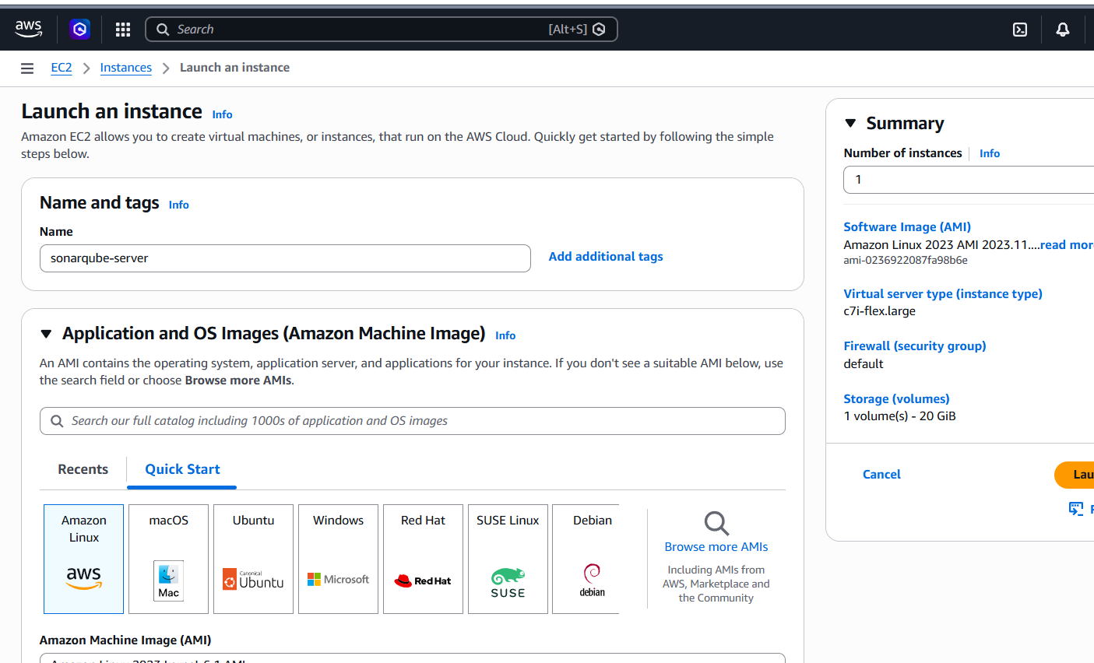
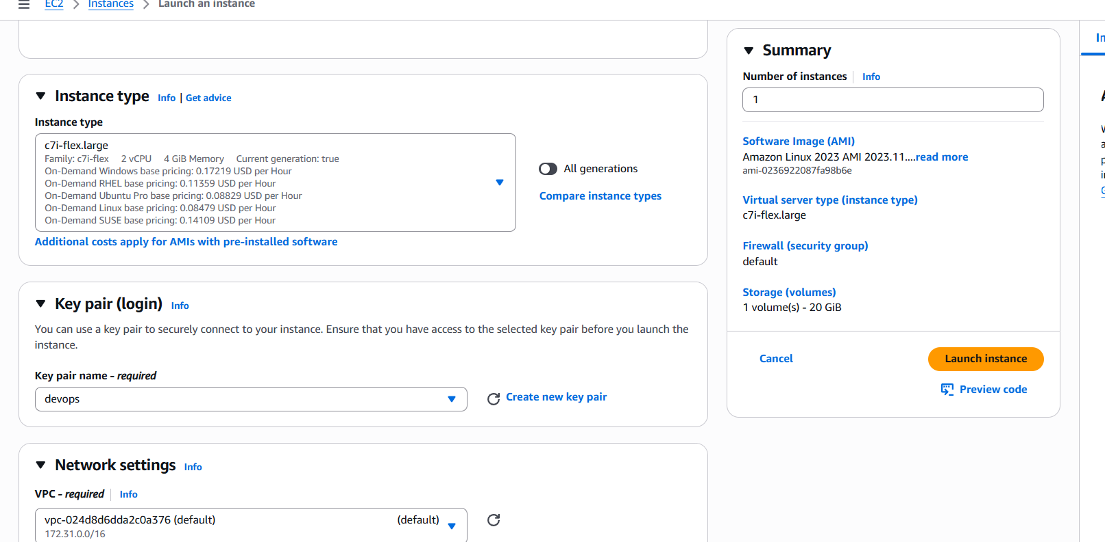
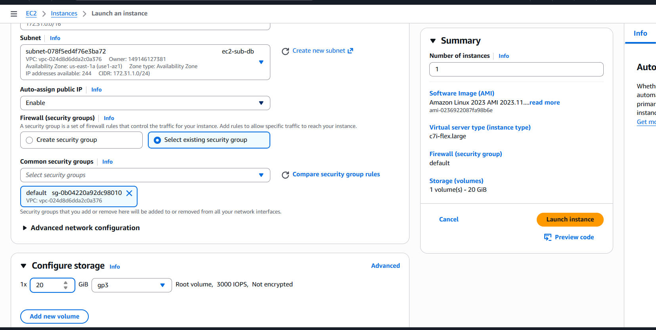
Created successfully
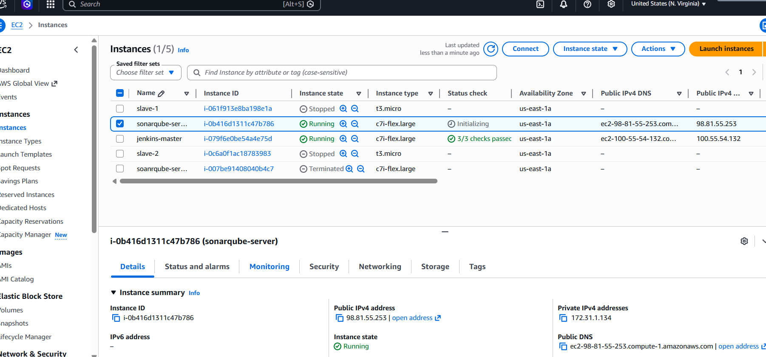
Connect to the server
Install java 1.8
yum install java-1.8.0-openjdk -y
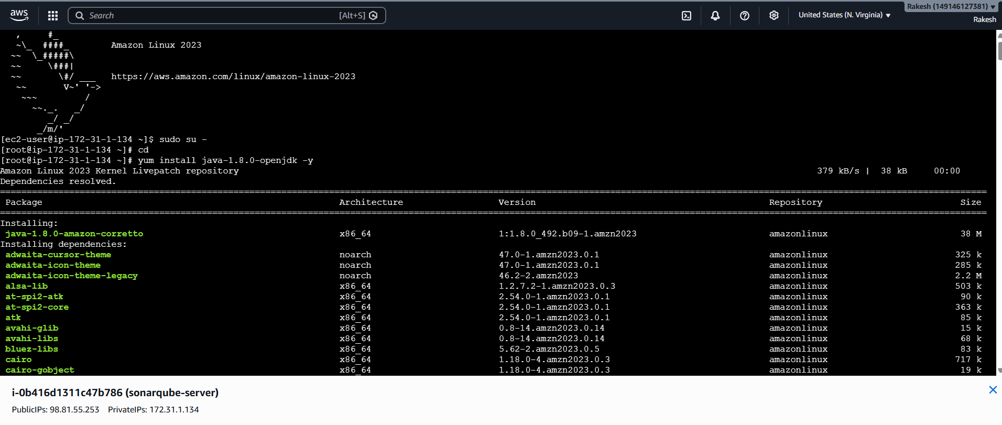
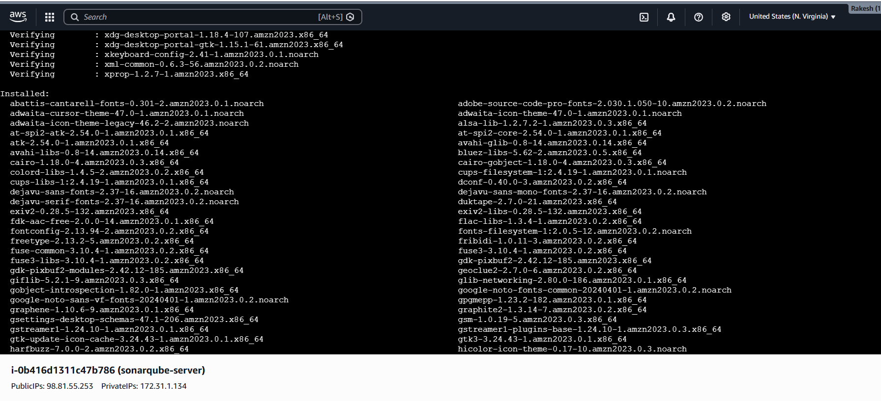
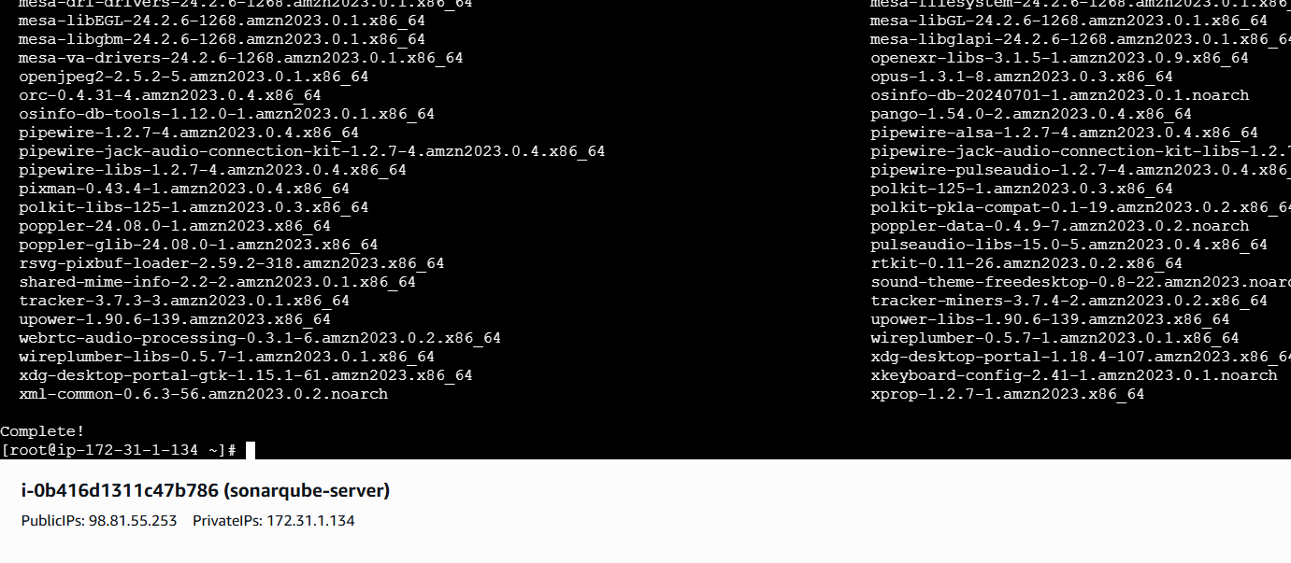
Install and Configure MySQL
- sudo wget https://dev.mysql.com/get/mysql57-community-release-el7-11.noarch.rpm
- sudo yum localinstall mysql57-community-release-el7-11.noarch.rpm
- rpm --import https://repo.mysql.com/RPM-GPG-KEY-mysql-2022
- sudo yum install mysql-community-server
- sudo systemctl start mysqld.service
- systemctl start mysqld
- systemctl enable mysqld
- To check mysql is running or not netstat -na | grep 3306
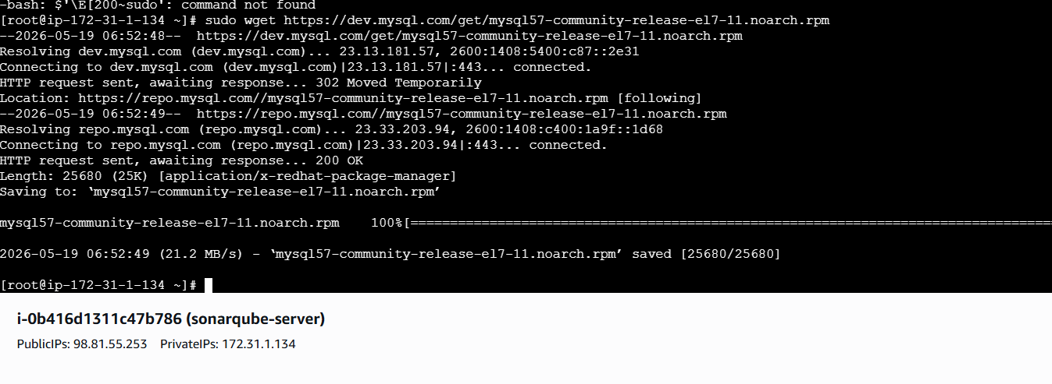
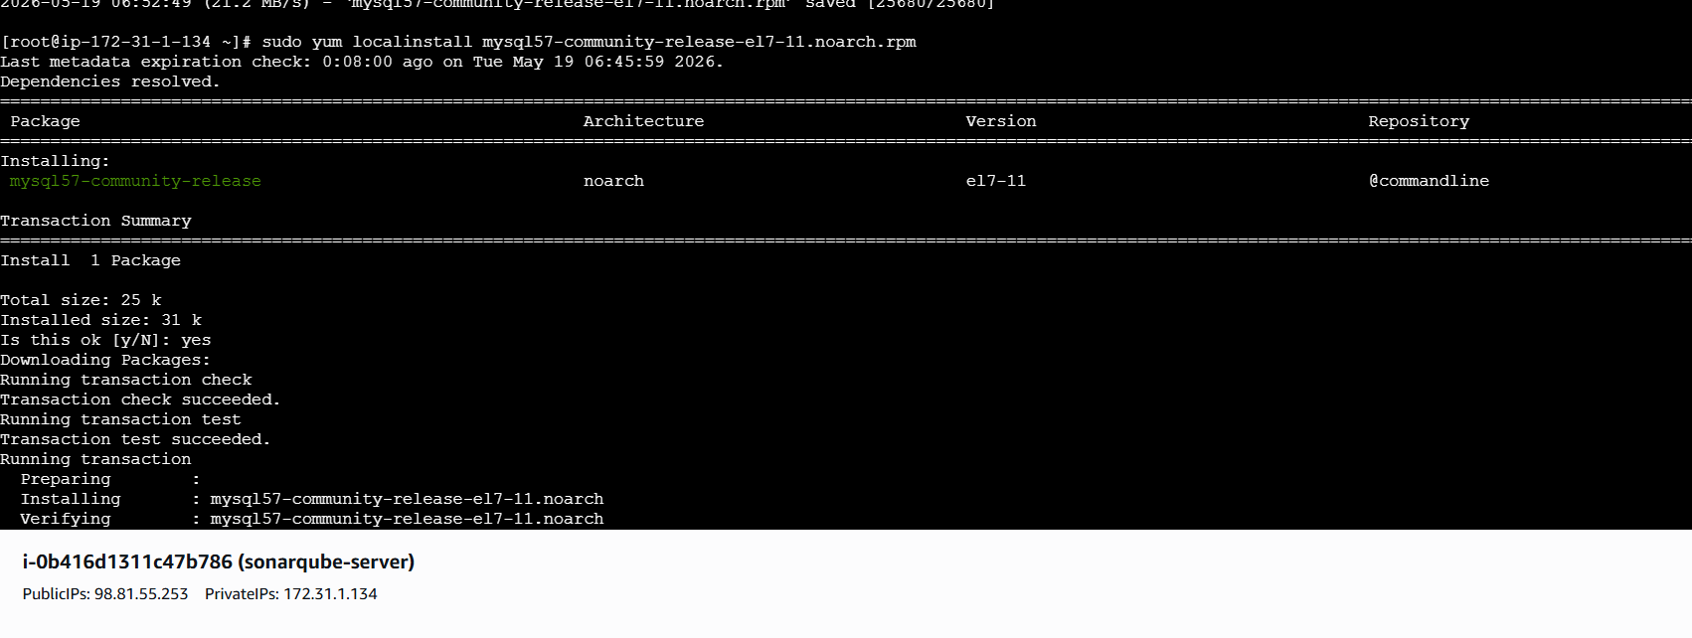
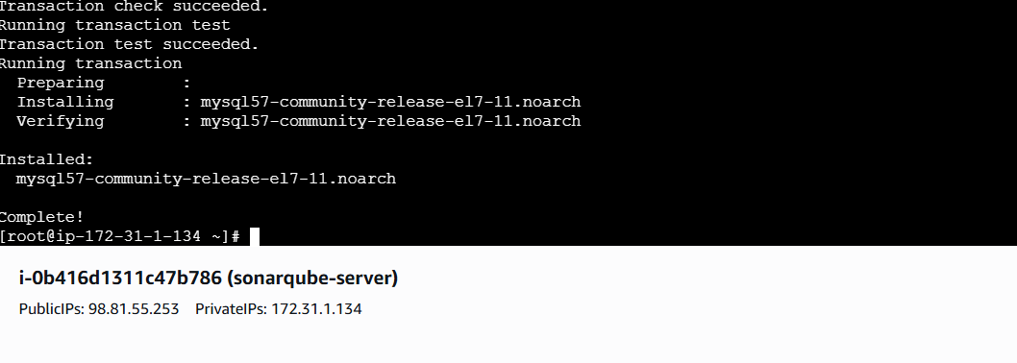
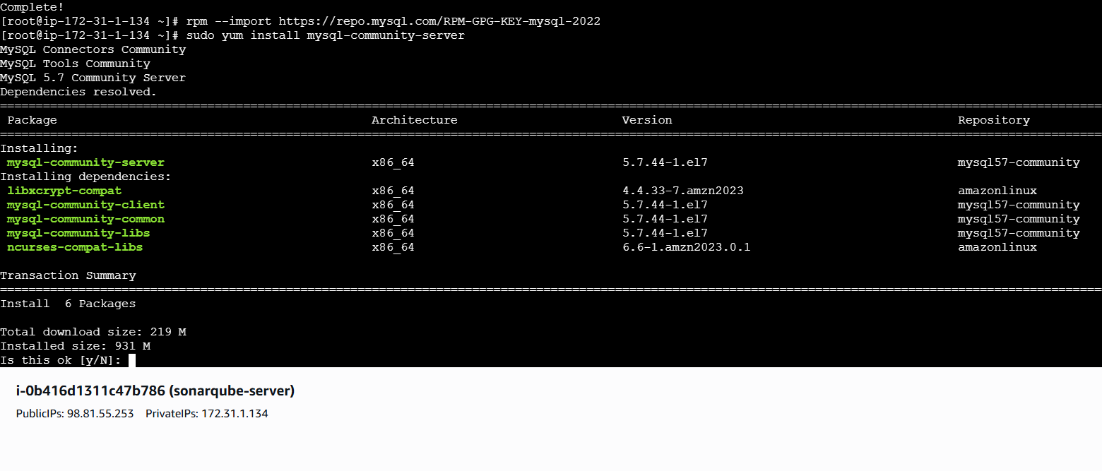
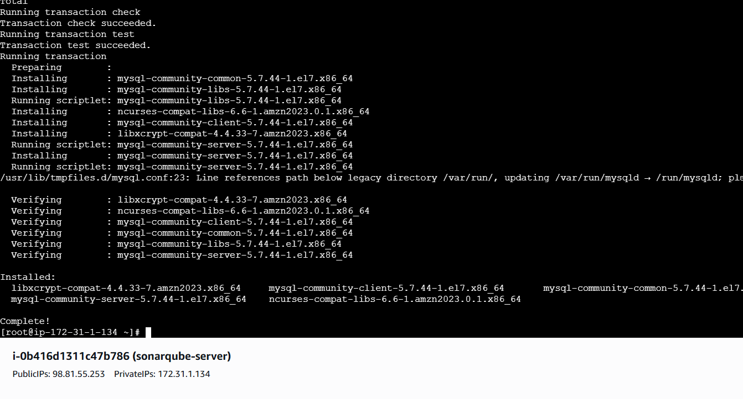
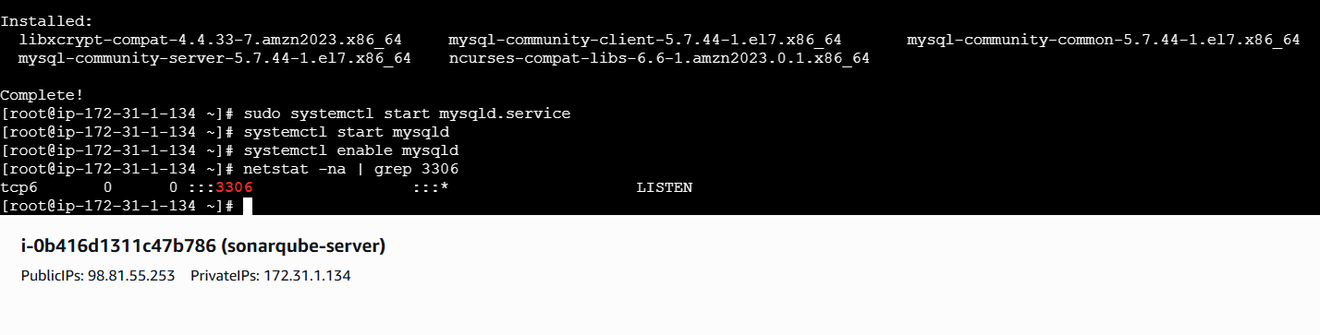
Configure the MySQL Root Password
--- Retrieve the temporary root password from /var/log/mysqld.log
We can see default MySQL root password grep 'temporary' /var/log/mysqld.log
First lets login to mysql using default password
mysql -u root -p
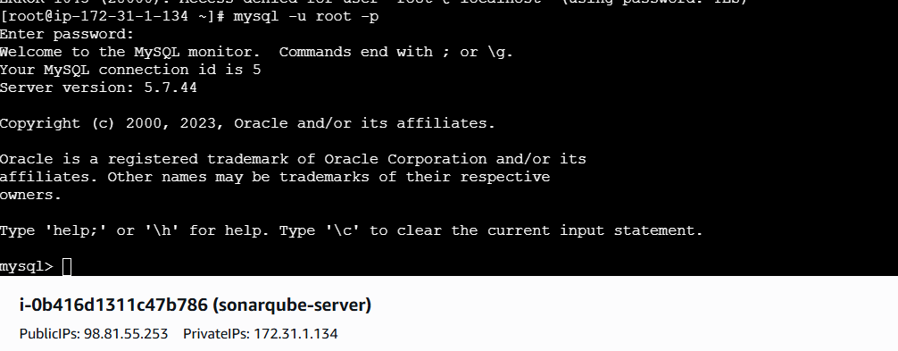
replace the default password with a new and strong password
ALTER USER 'root'@'localhost' IDENTIFIED BY 'Admin@123';
flush privileges;
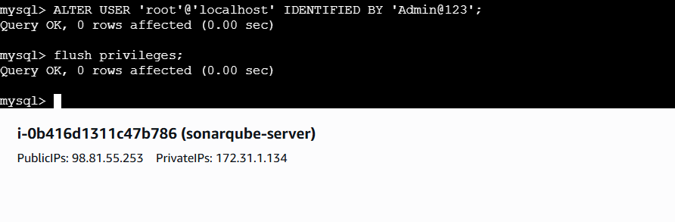
Tried to login to mysql with new password
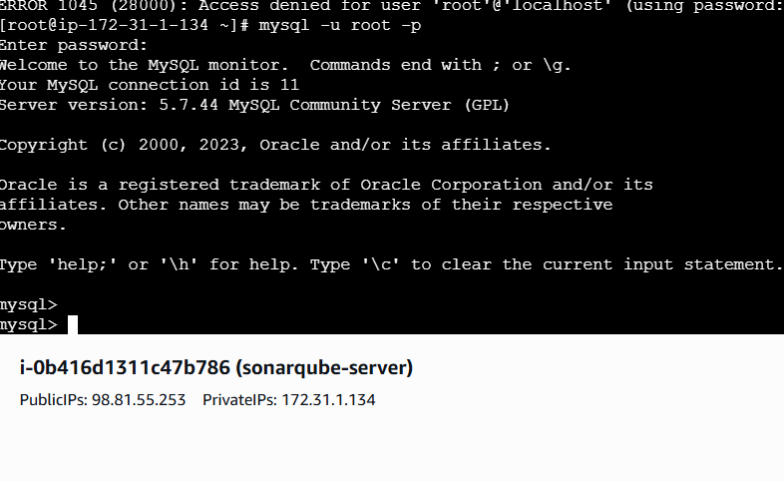
SonarQube Installation
To install sonarqube, goto --cd /opt/
To download -- wget
https://binaries.sonarsource.com/Distribution/sonarqube/sonarqube-6.6.zip
To Unzip -- unzip sonarqube-6.6.zip
To Rename -- mv /opt/sonarqube-6.6 /opt/sonar

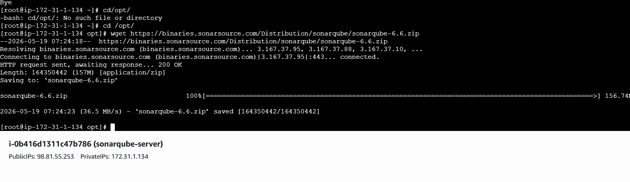
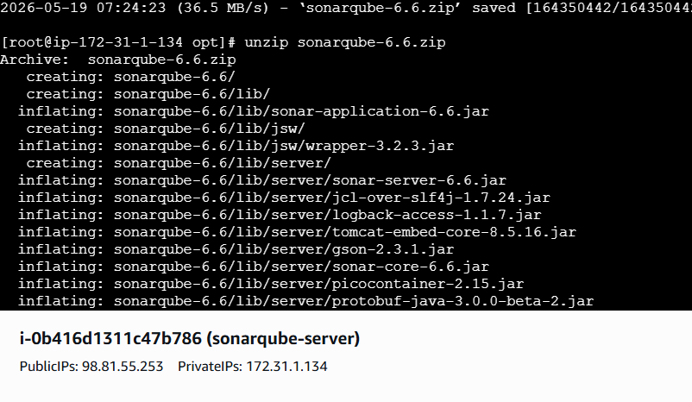
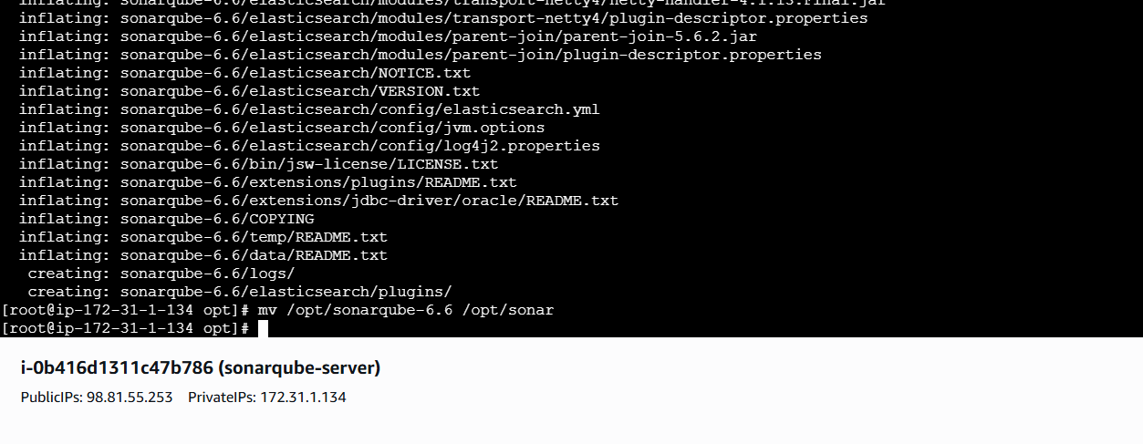
Created Databases and users, Gave the users the permissions and checkied if we did right
or
not.
Steps Involves and commands used
Create a new sonar database
CREATE DATABASE sonar CHARACTER SET utf8 COLLATE utf8_general_ci;
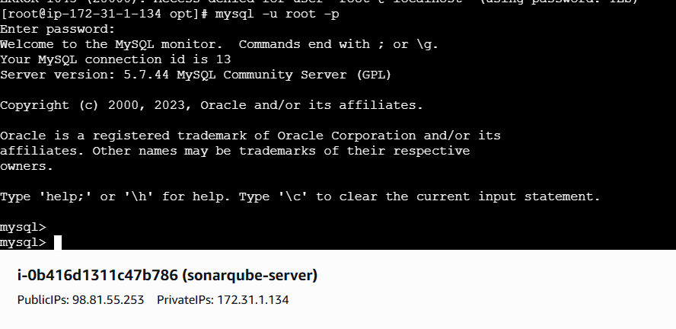
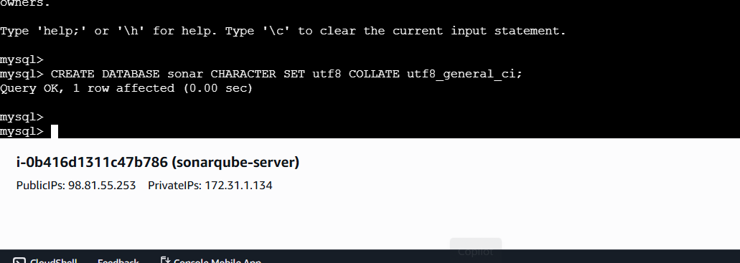

Create a local and a remote user
CREATE USER sonar@localhost IDENTIFIED BY 'Sonar@123';
CREATE USER sonar@'%' IDENTIFIED BY 'Sonar@123';
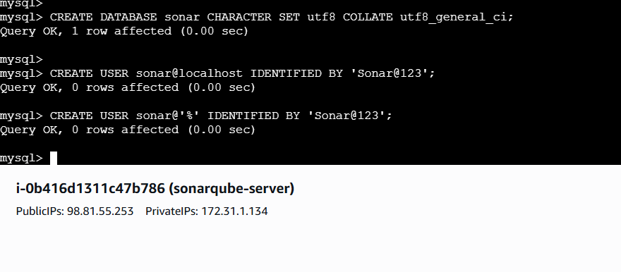
Grant database access permissions to users
GRANT ALL ON sonar.* TO sonar@localhost;
GRANT ALL ON sonar.* TO sonar@'%';
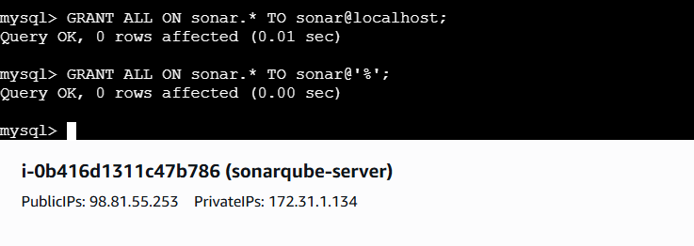
To check databases -- show databases;
To check users -- SELECT User FROM mysql.user;
FLUSH PRIVILEGES;
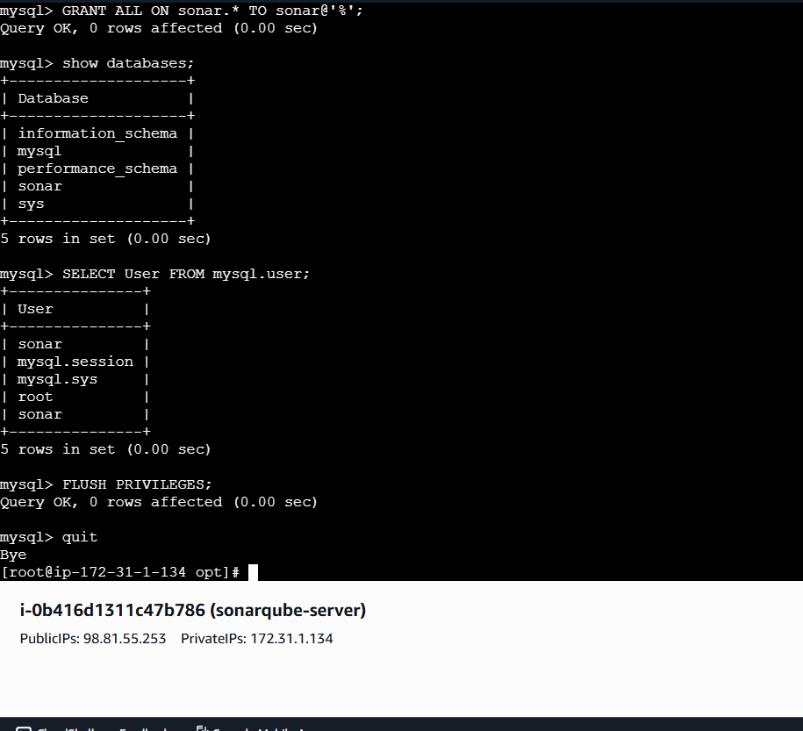
Lets enable SonarQube properties file to connect to the database
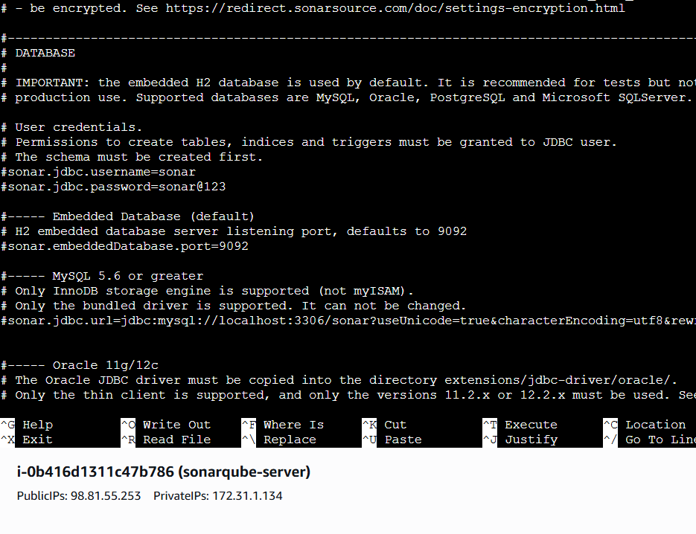
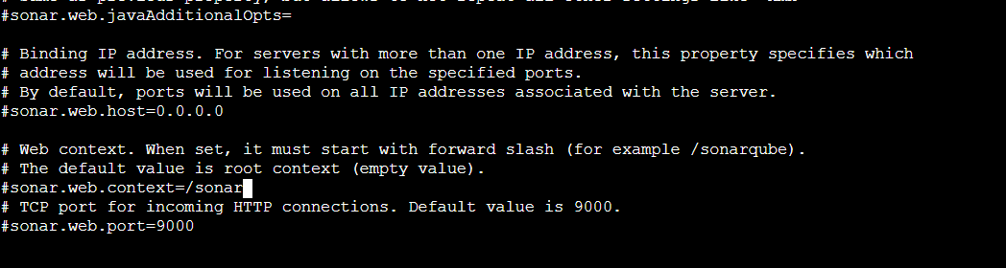
cd /opt
sudo unzip sonarqube-6.6.zip
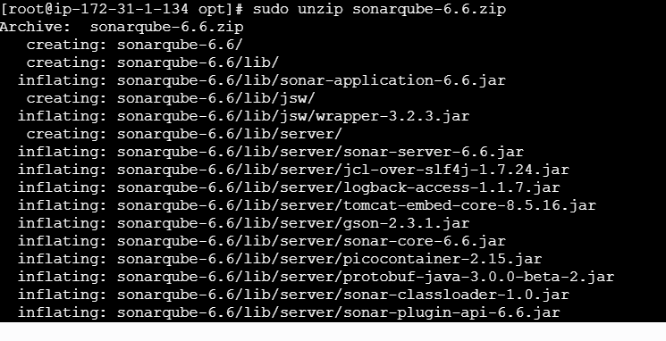
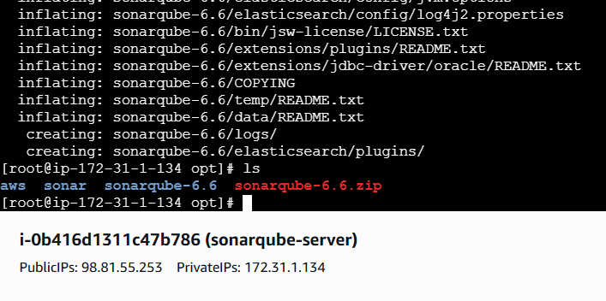

Created user
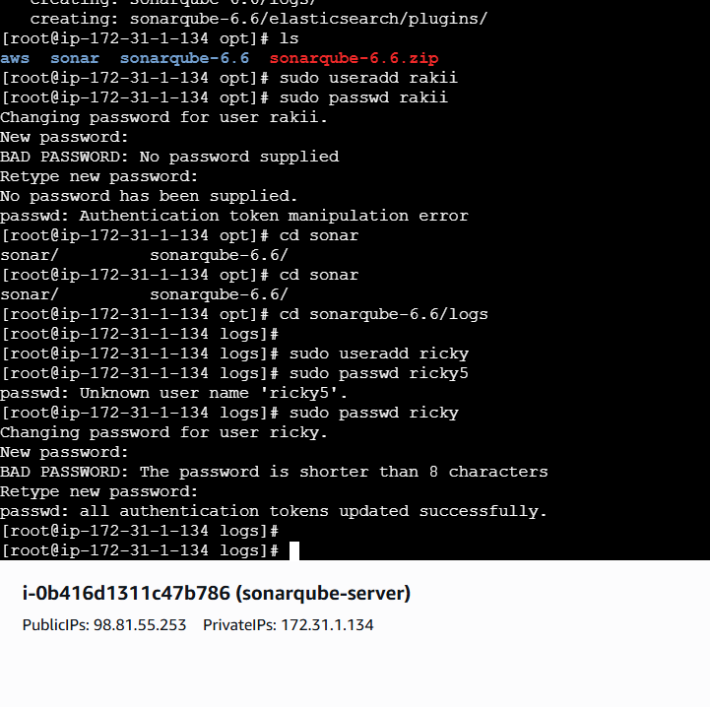
Switched to user
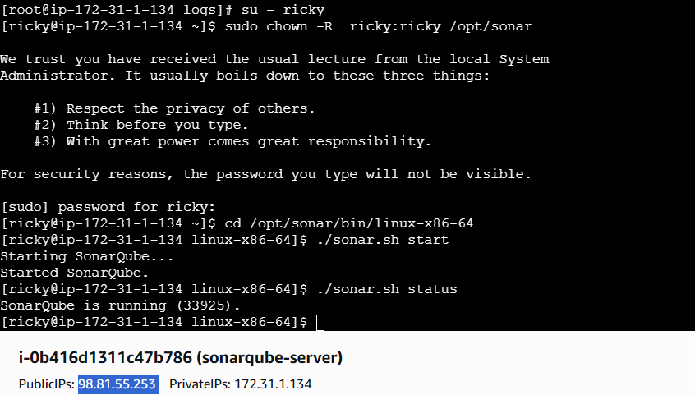
Started sonarqube

Successfully logged into sonarqube server

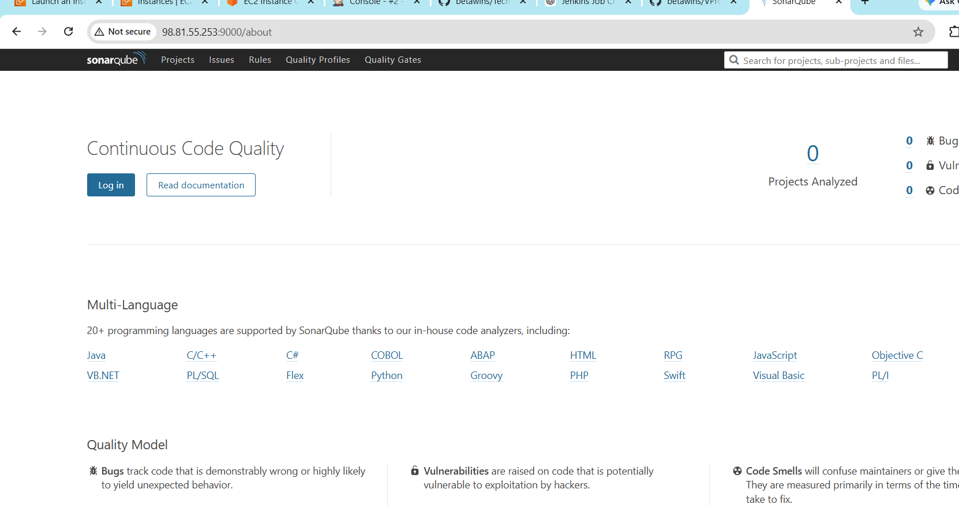
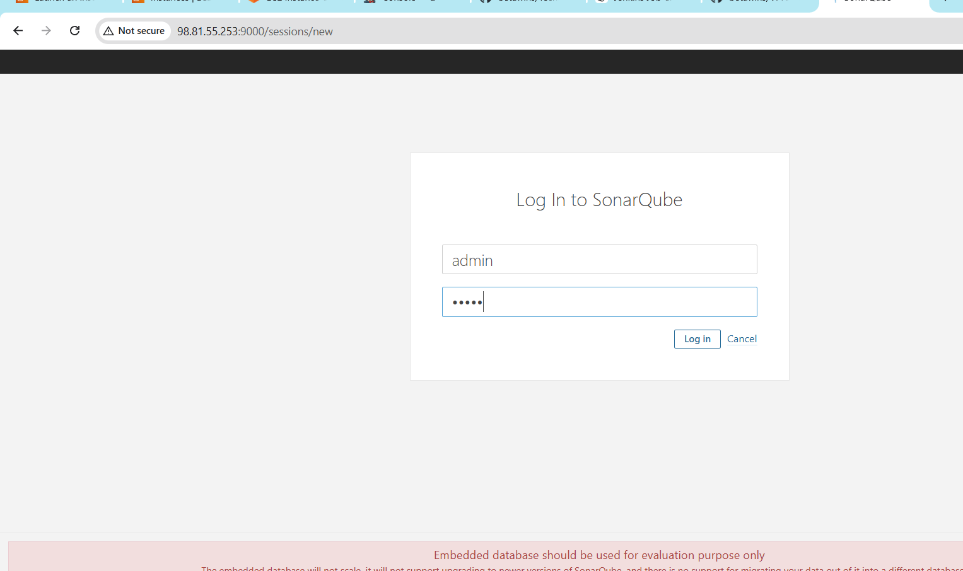
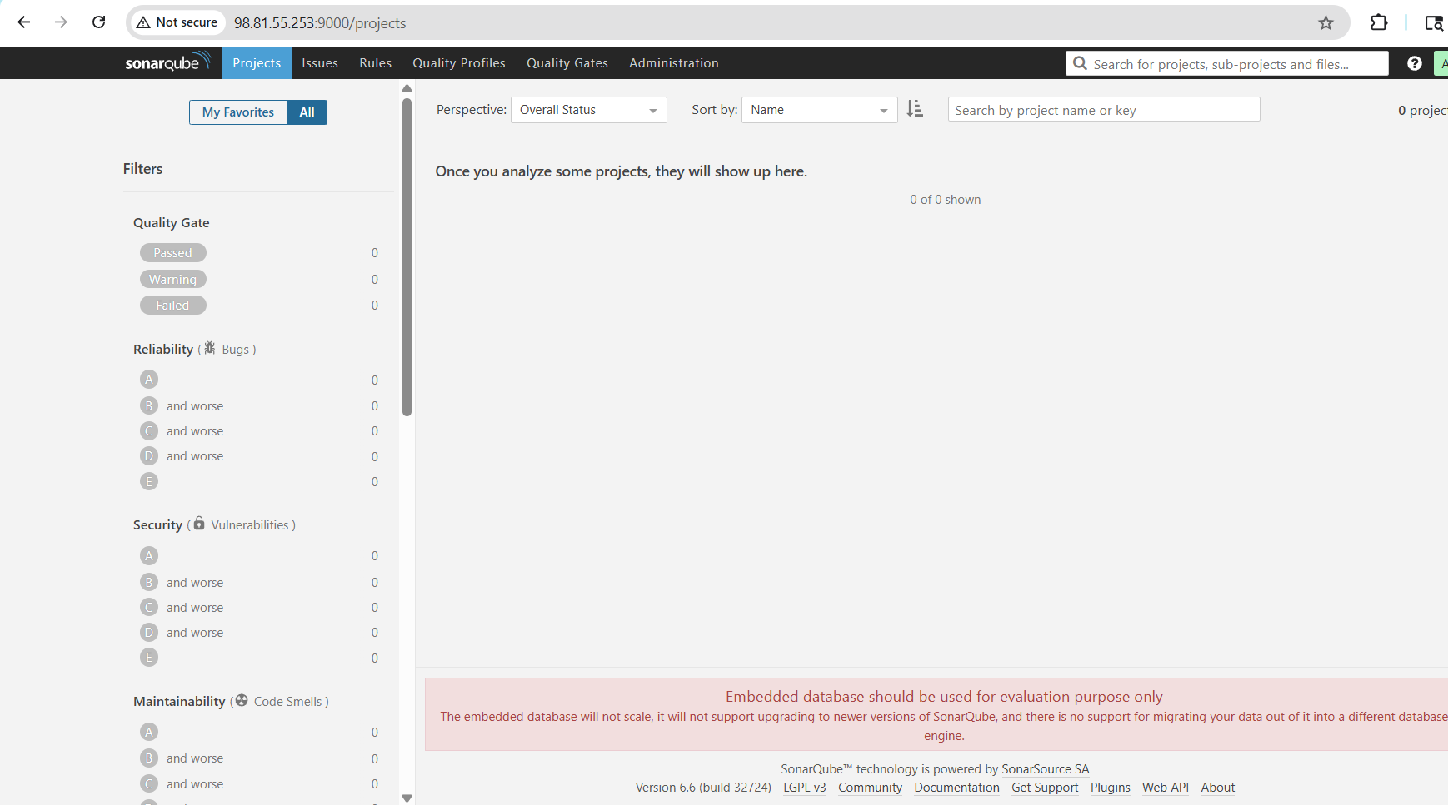
SonarQube Scanner on our Jenkins
Go to Manage Jenkins --- Plugins -- Sonarcube scanner -- click on Install
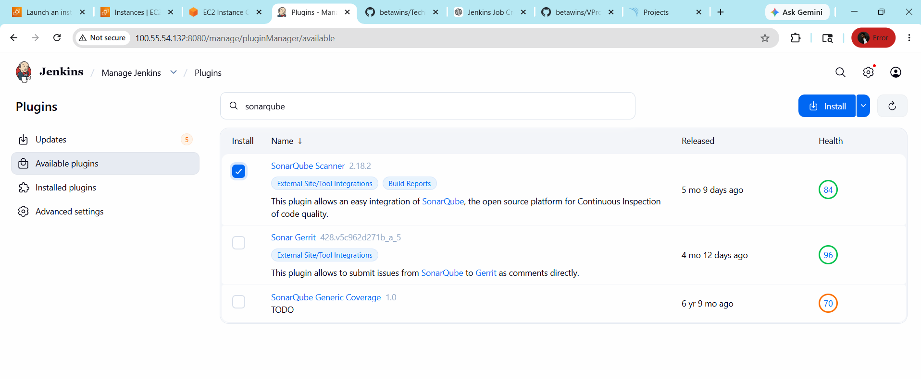
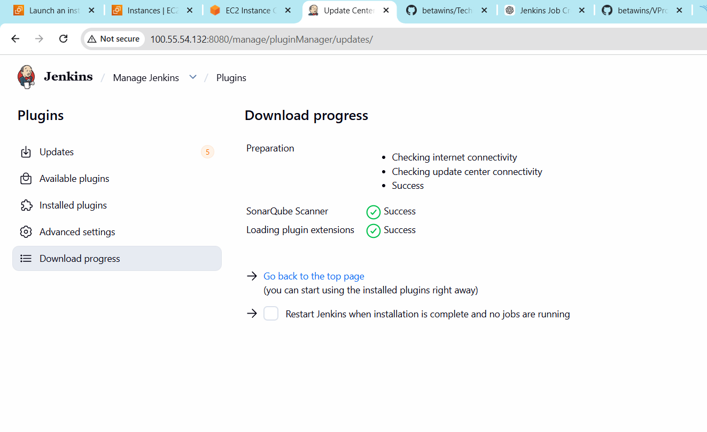To create
Manage Jenkins -- click on system -- SonarQube server -- give Name -- Server URL --
Credentials
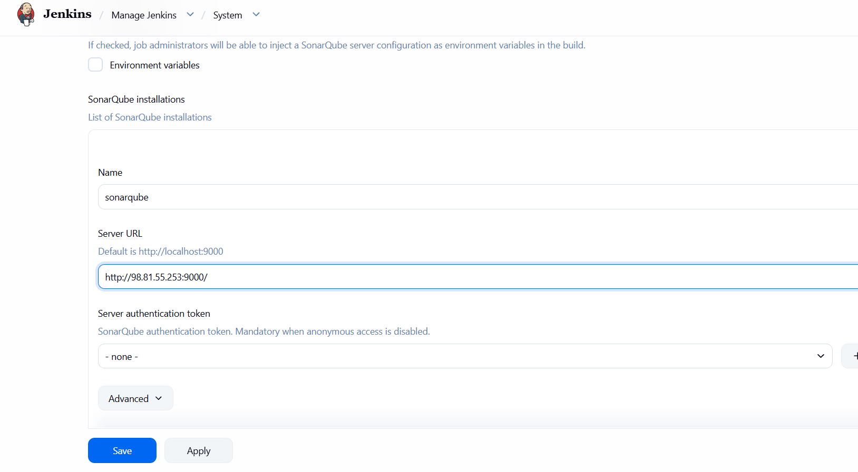

Generate an Authentication Token in SonarQube
--- Log into SonarQube → My Account → Security → Generate Tokens ---Copy the generated token.
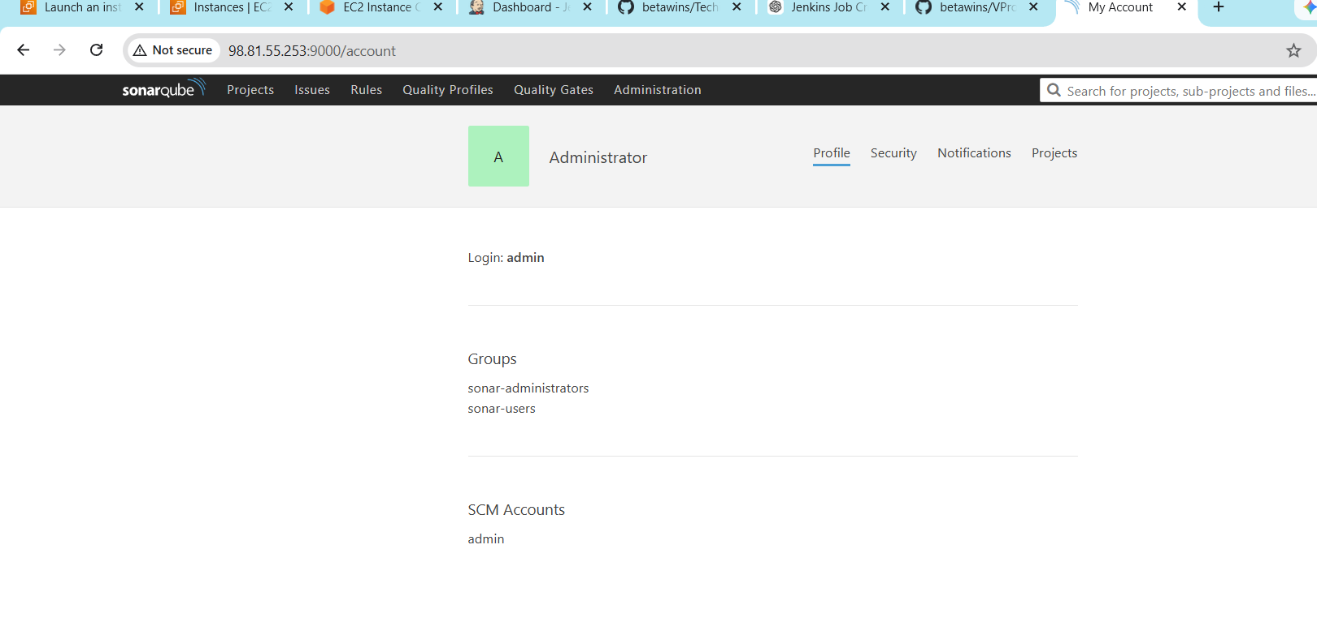
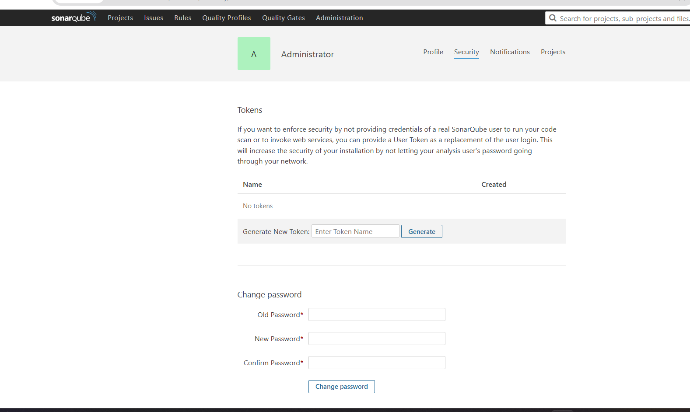
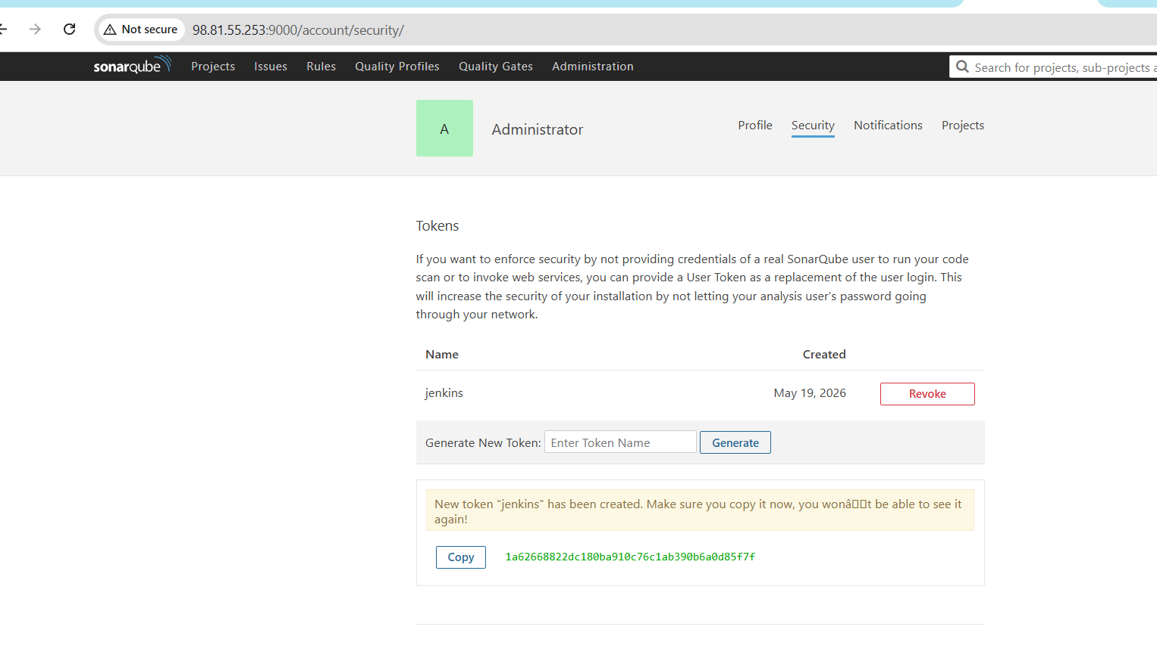
Add it to Jenkins credentials
Go to manage Jenkins -- click on credentials
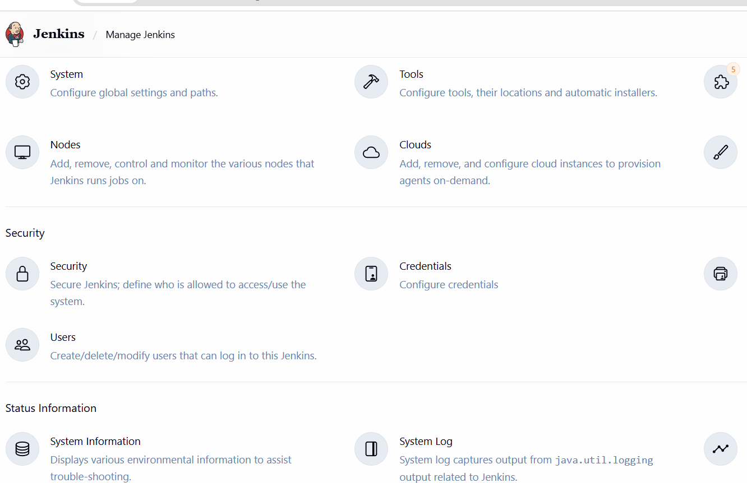
Click on global --add credentials -- secret text
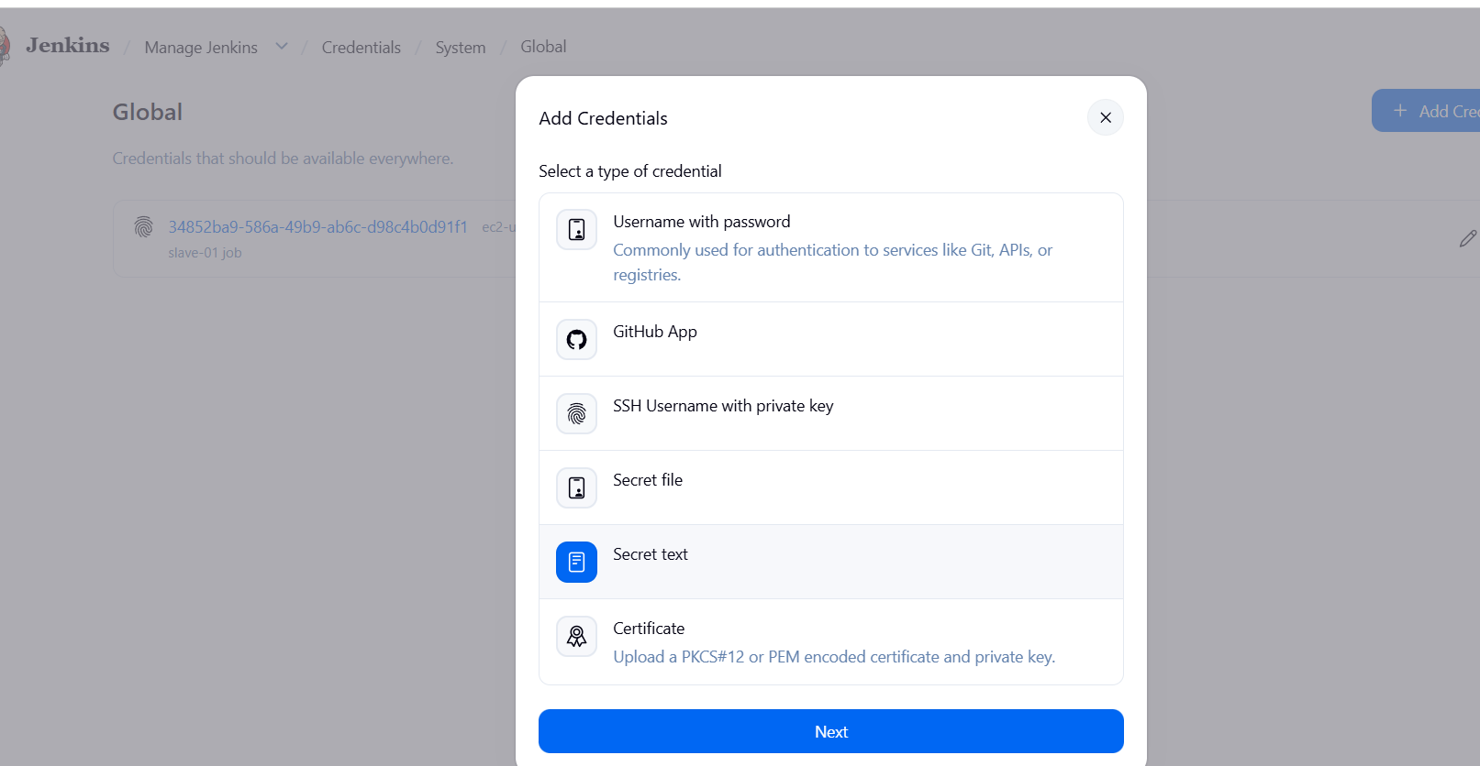
Paste the token
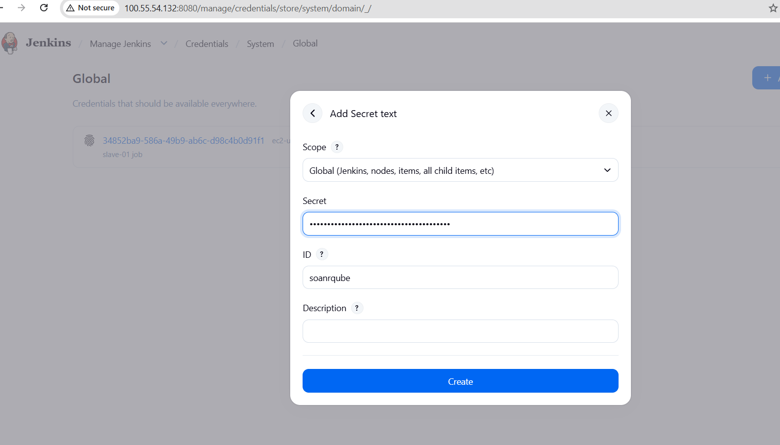

Created credentials
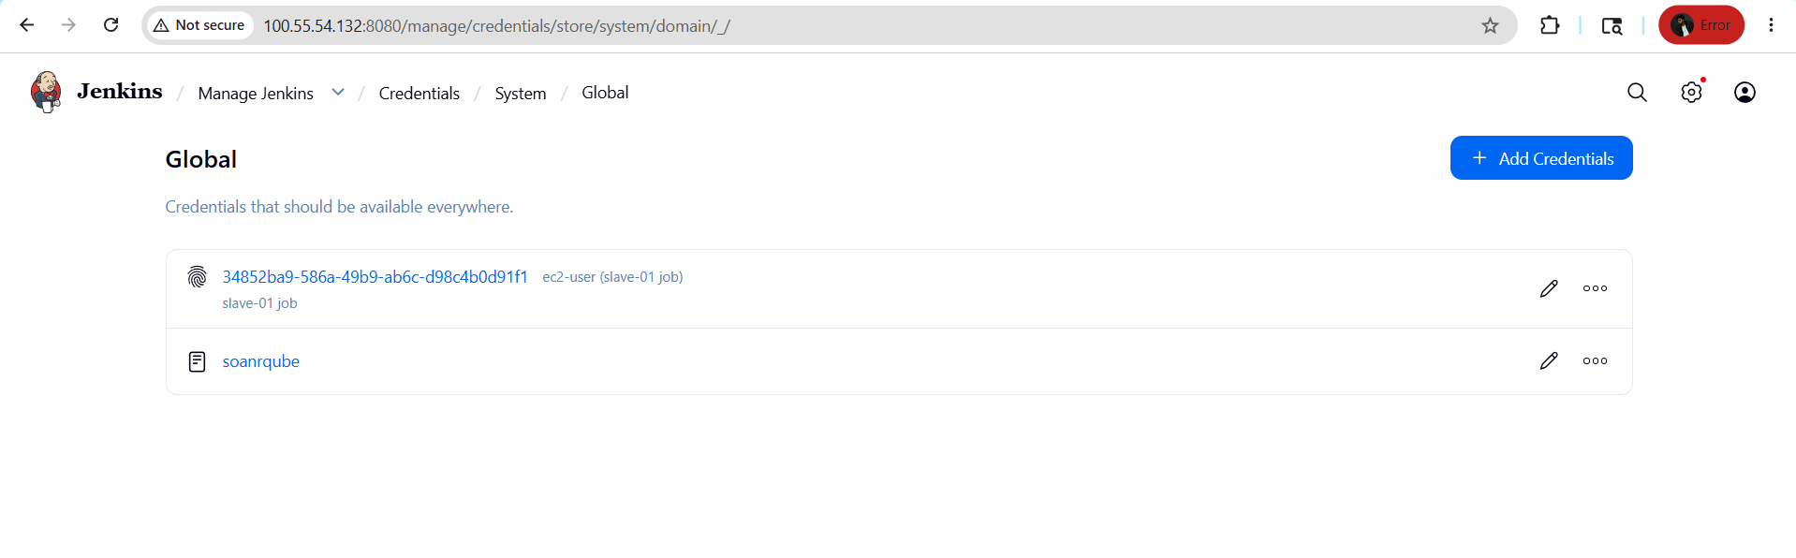
add the credential in the configurations
go to manage Jenkins click on system choose sonarqube server add credential to server authentication token
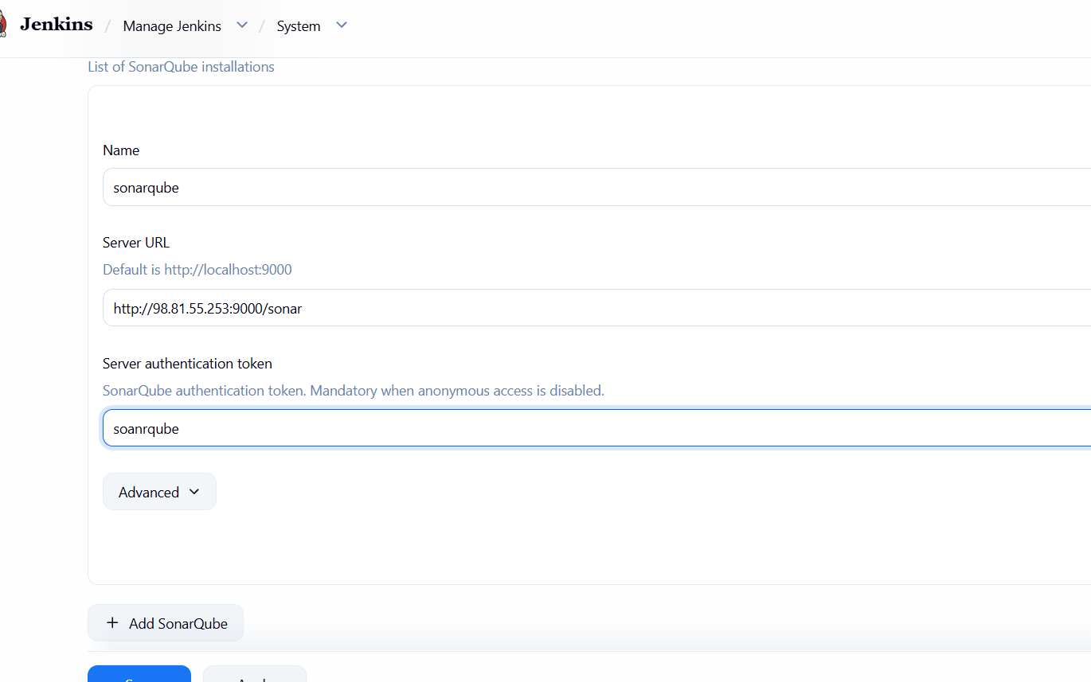
We need to install sonarqube-scanner in Jenkins server
To Download - wget https://binaries.sonarsource.com/Distribution/sonar-scanner-cli/sonar-scanner-cli-3.2.0.1227-linux.zip
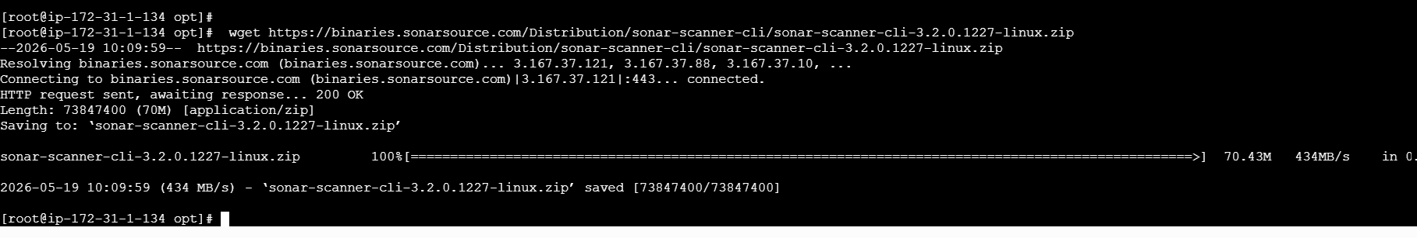
To Unzip - unzip sonar-scanner-cli-3.2.0.1227-linux.zip
- To Rename - mv sonar-scanner-3.2.0.1227-linux /opt/sonar_scanner
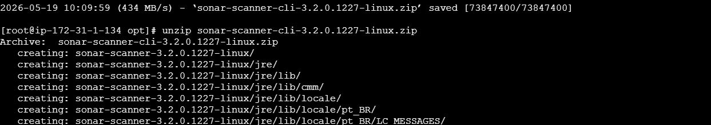
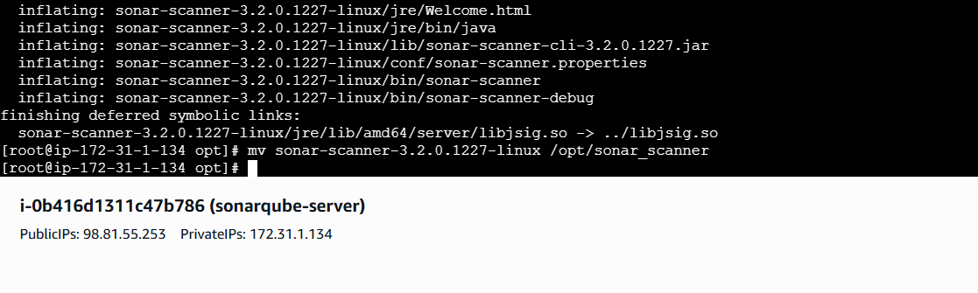
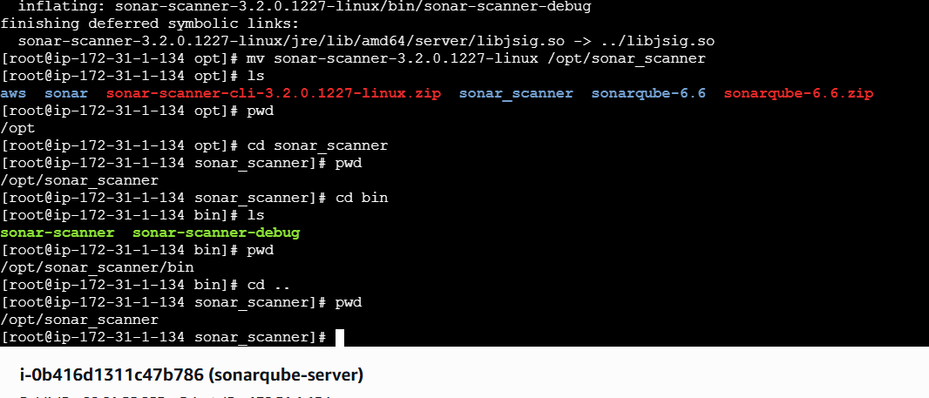

Add the above sonar-scanner path in the Jenkins
Go to manage Jenkins sonarQube Scanner Name Path Save
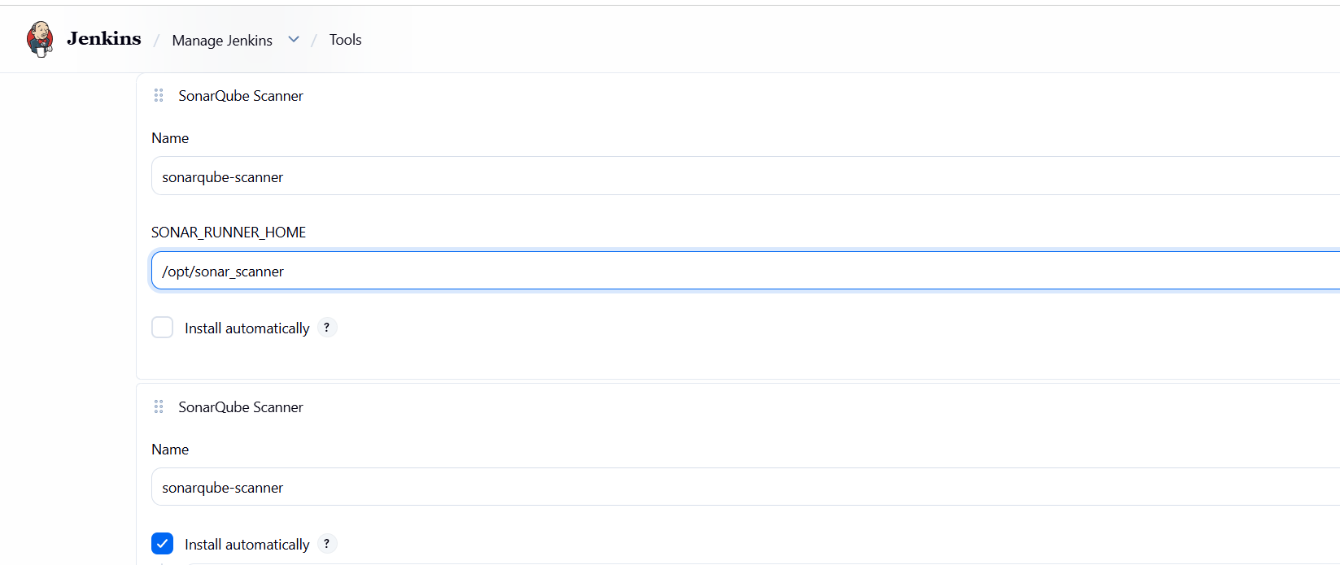
Next We need to give analysis properties of the code to run in the Job we created
Job --Configure → Build Steps → Analysis Properties(we will get it from developers)
-- Save

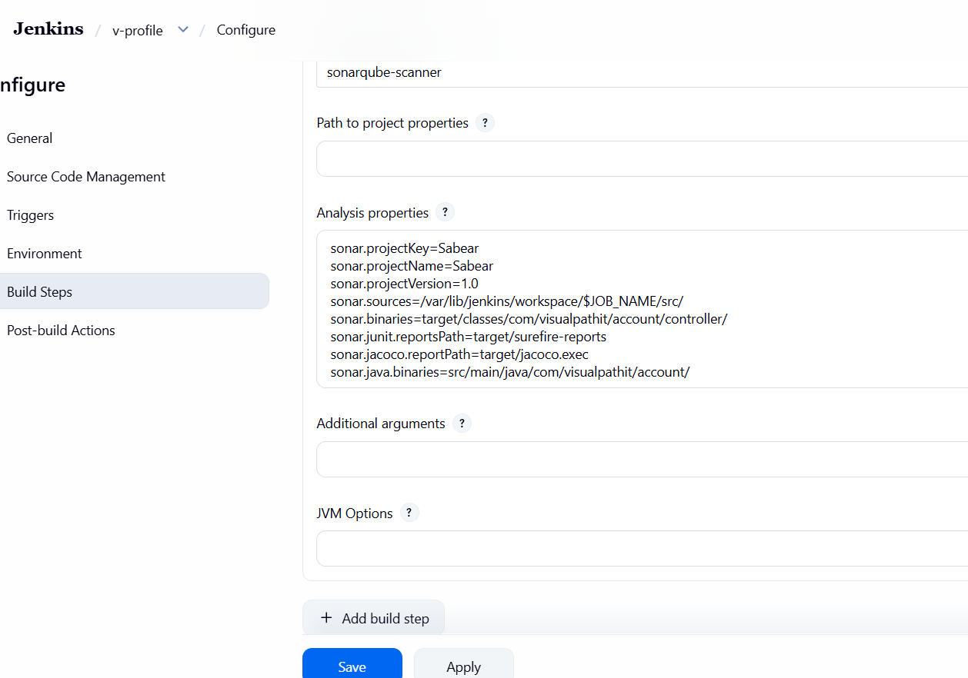
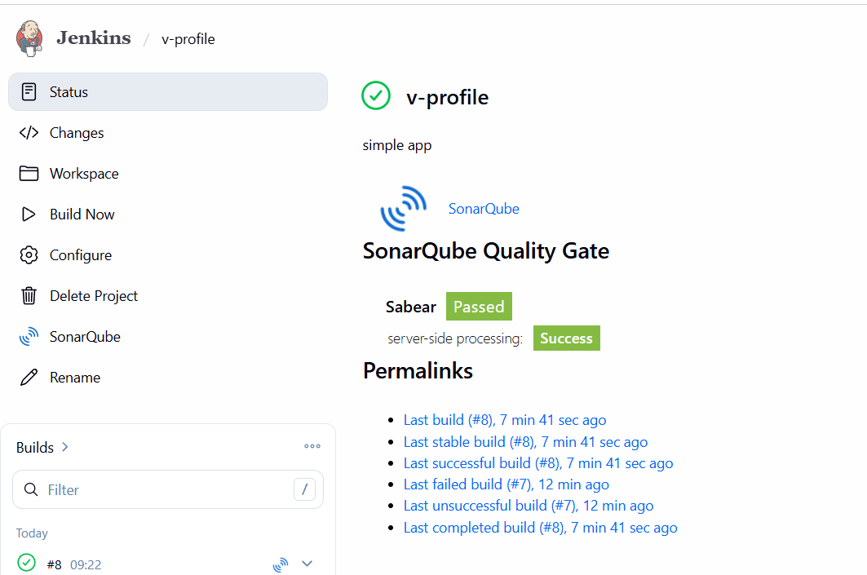
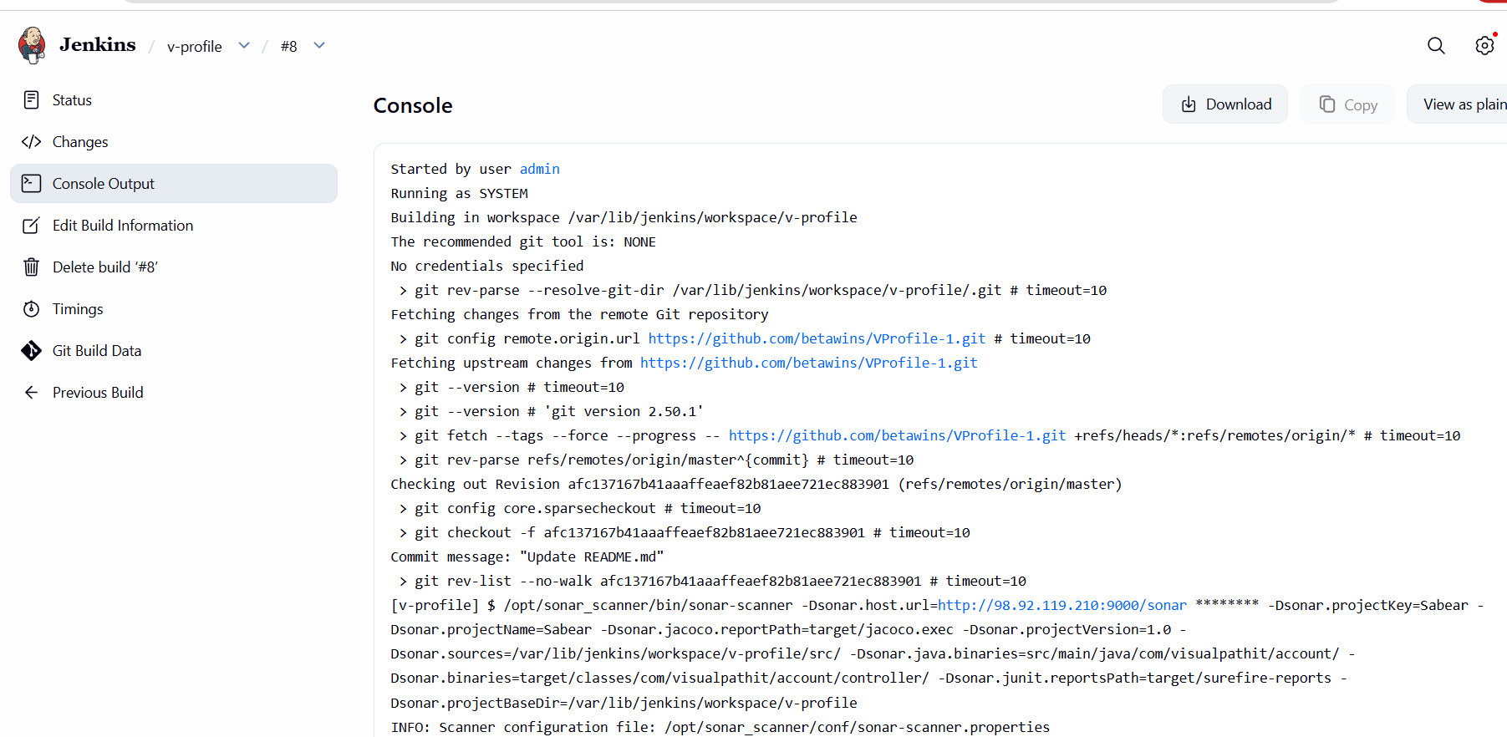
It also passed in sonarqube
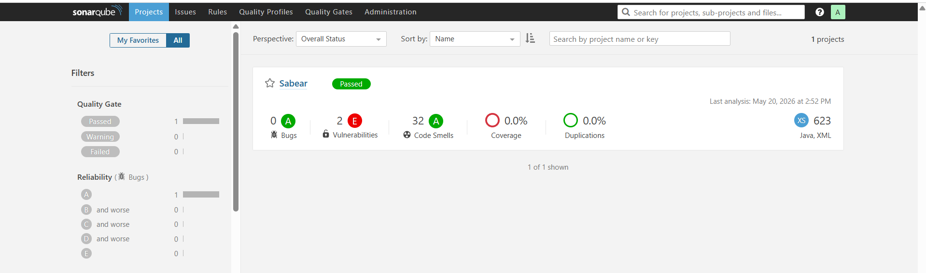

- stage3: Slack Integration to send the alerts to slack.
Go to manage Jenkins --- plugins -- available plugins -- search for slack notification --
Install
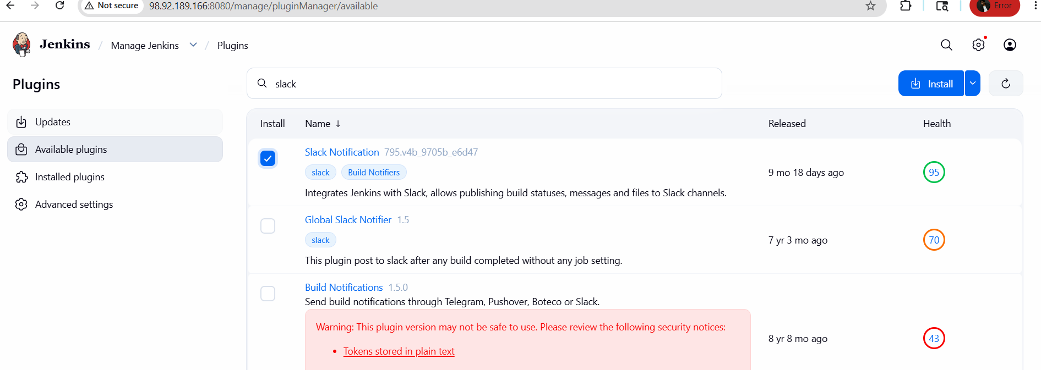
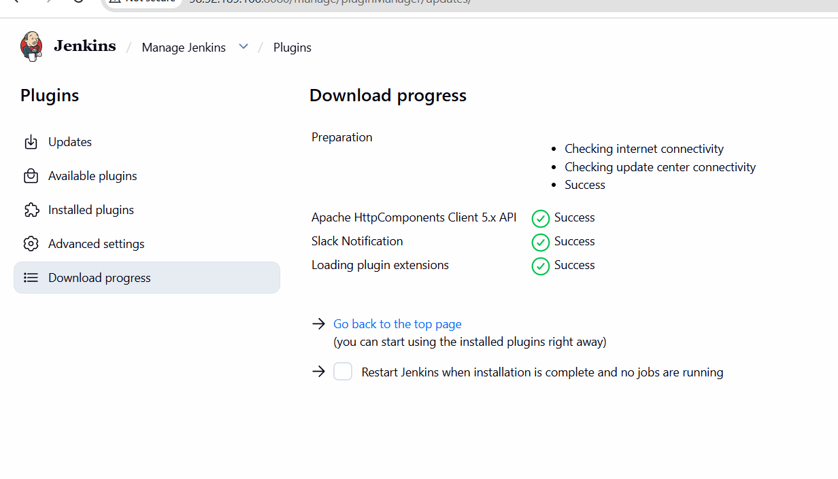
I have created a slack account
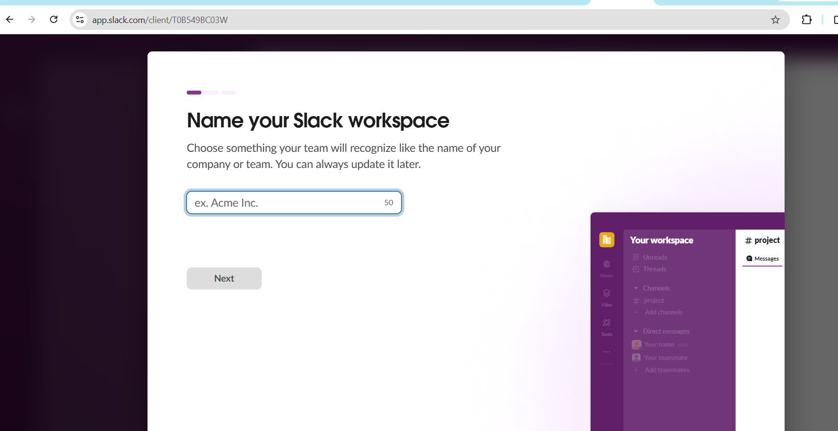
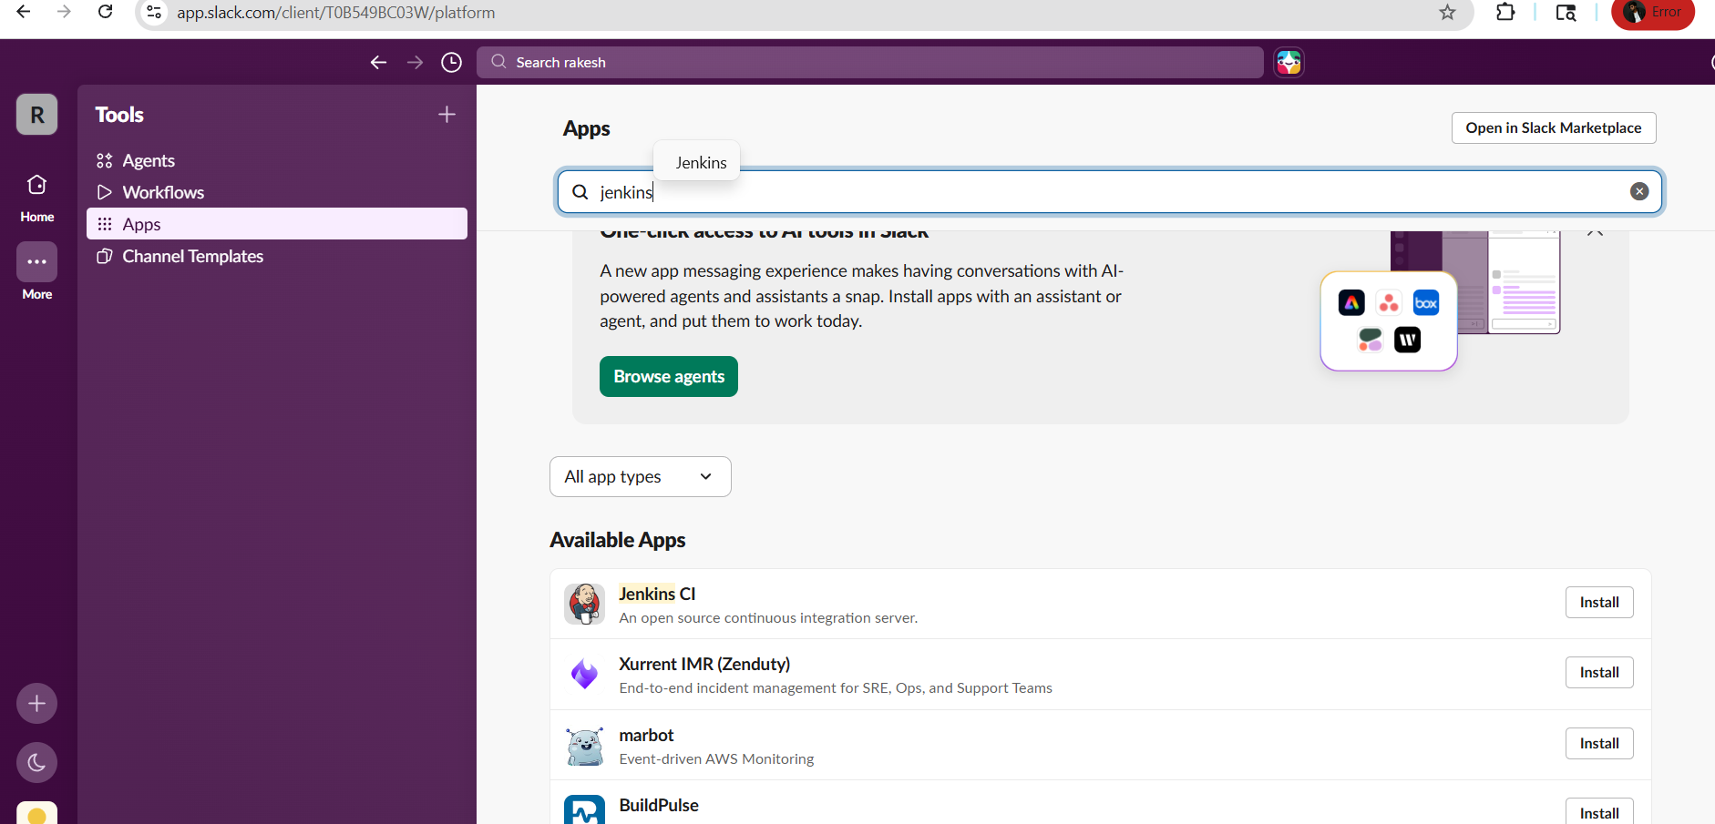
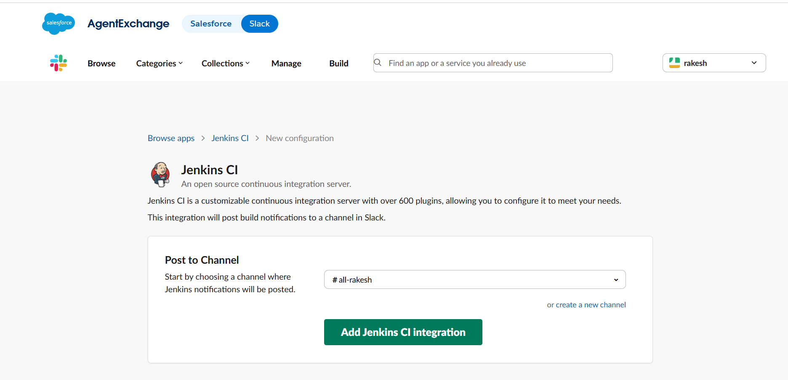
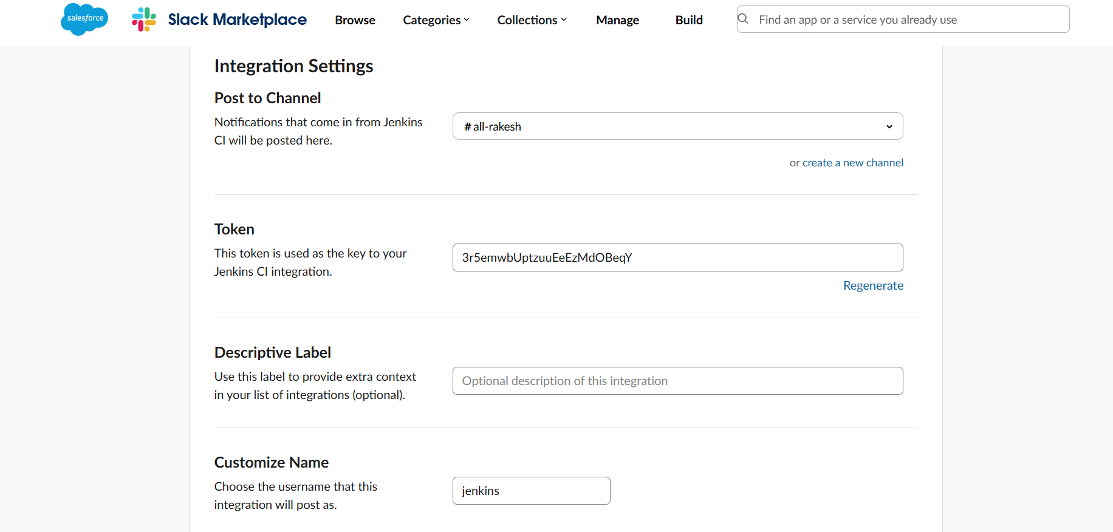
Go to manage Jenkins-- credentials -- click on secret text -- add the copied token in
secret
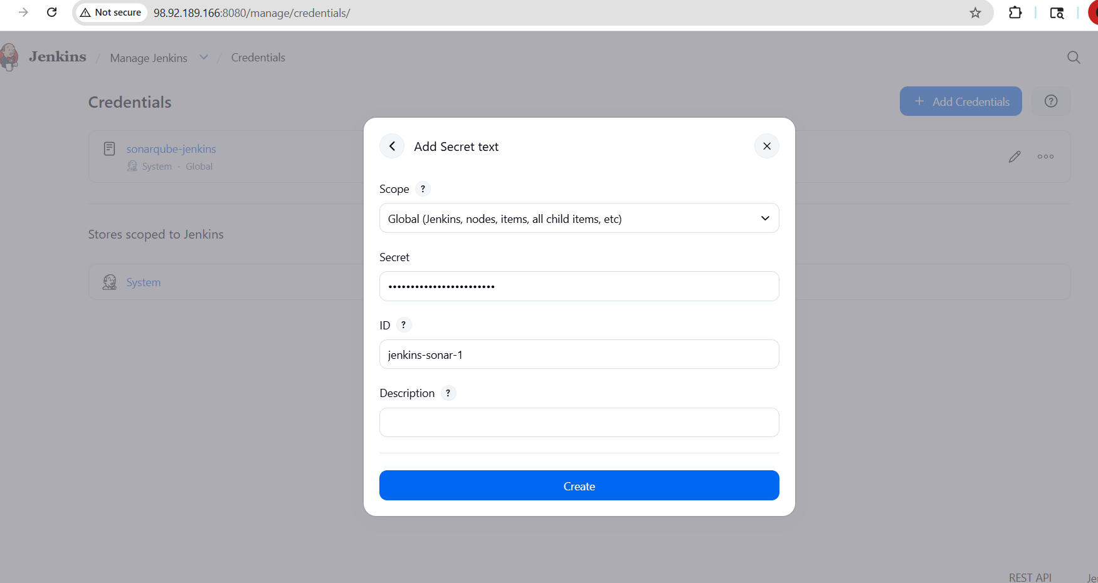
If we open the channel in slack there we will be having channel id, copy that and give in channel id section
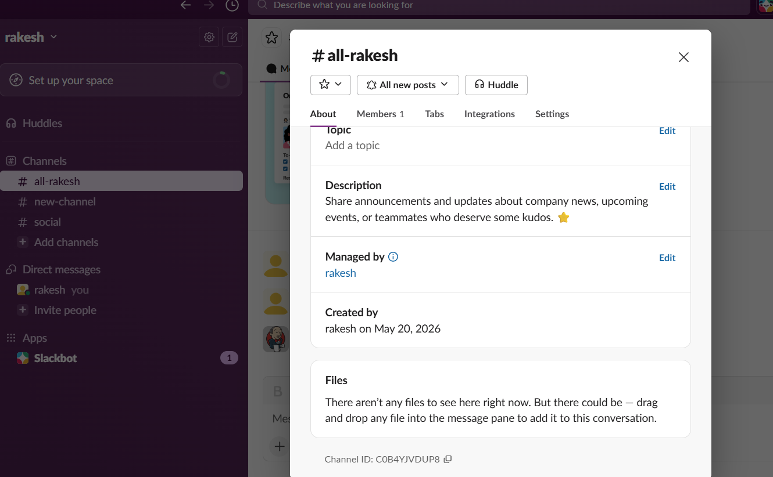

Go to manage Jenkins-- click on build -- go to post build actions -- enter slack workspace-- select credentials --give channel id -- click on test connection
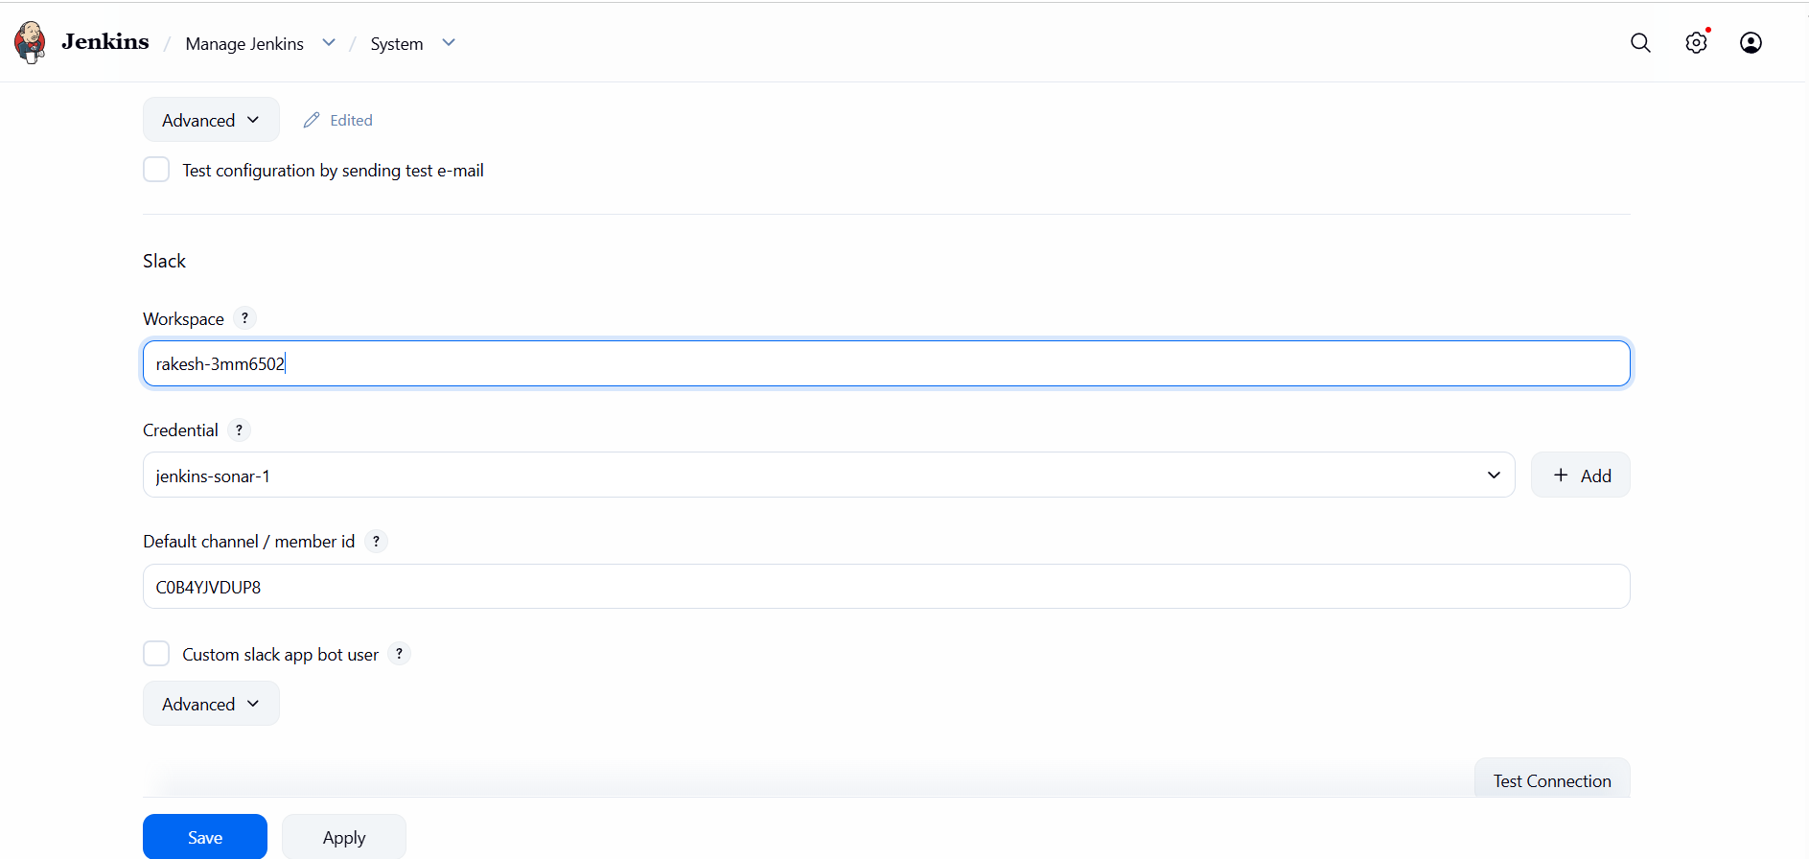
When we click on build it is successfully ran
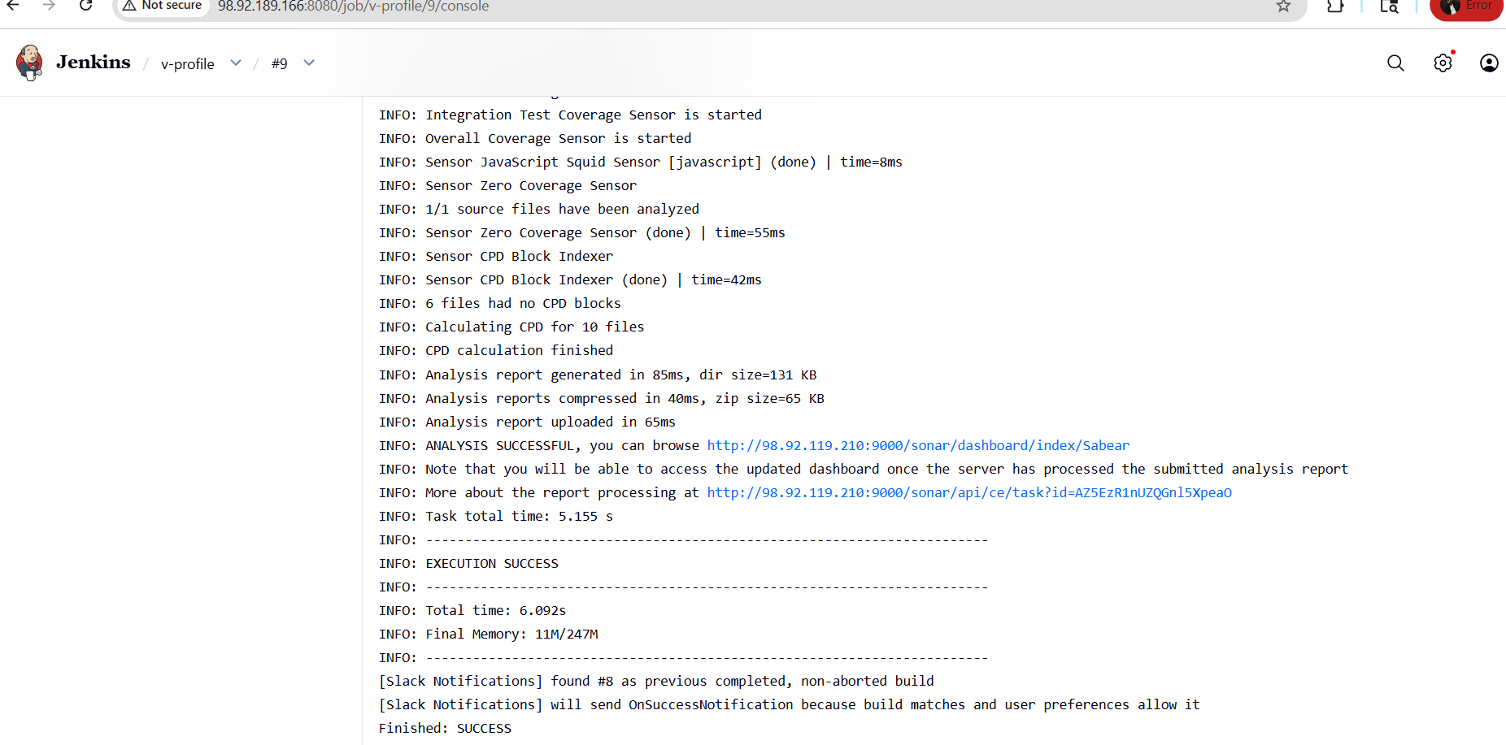
Also we are able to get the alerts in slack
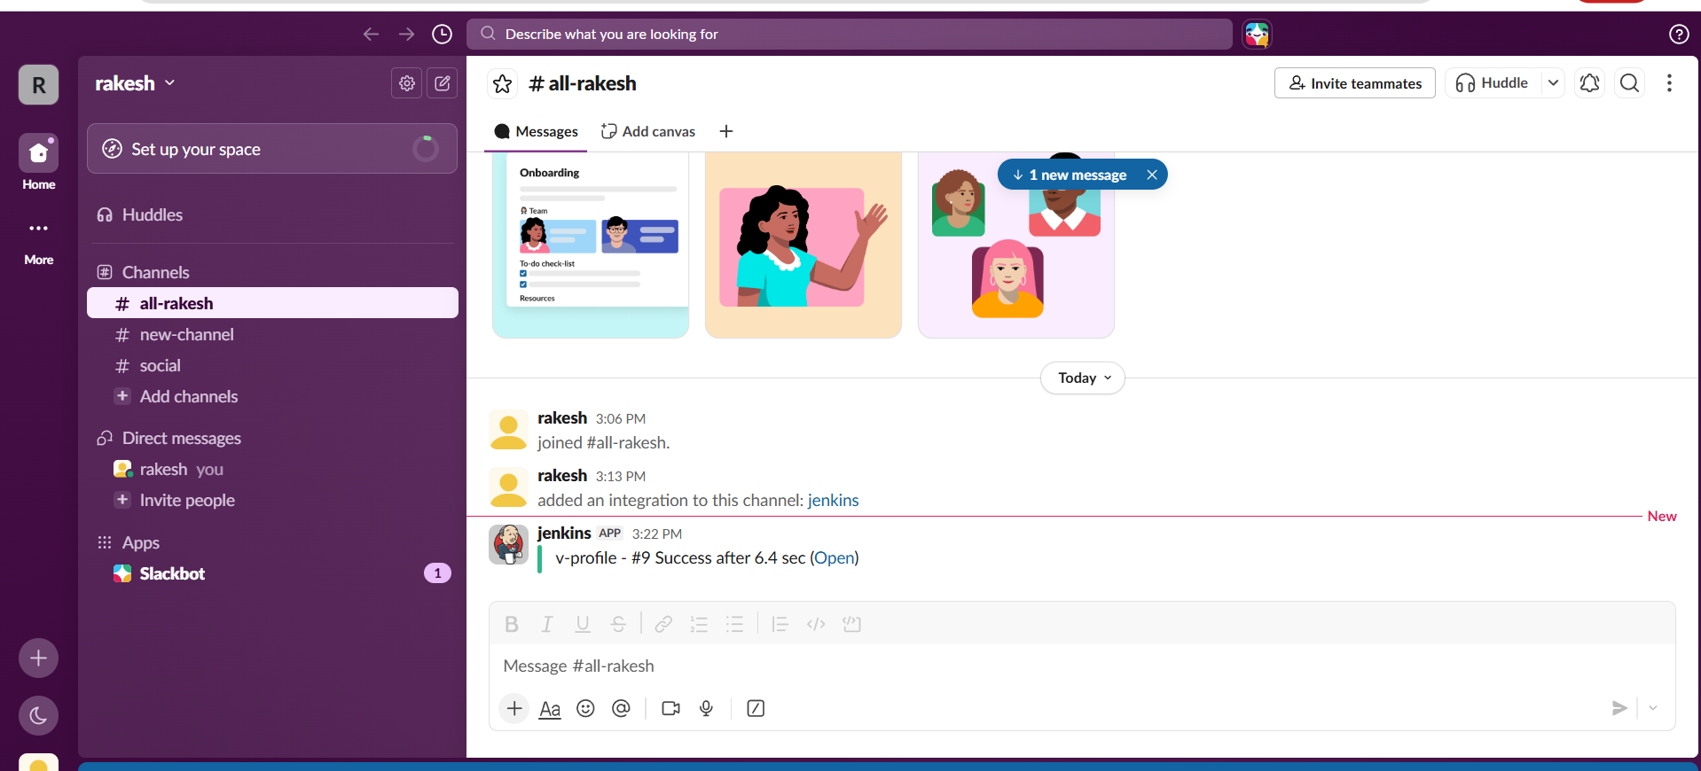

2. Create one Jenkins job using the below code and create three stages.
- stage1: Git clone to download the source code.
- stage2: Sonarqube Integration to check the quality of code.
- stage3: Slack Integration to send the alerts to slack.
Source Code: https://github.com/betawins/hiring-app.git
create a new build
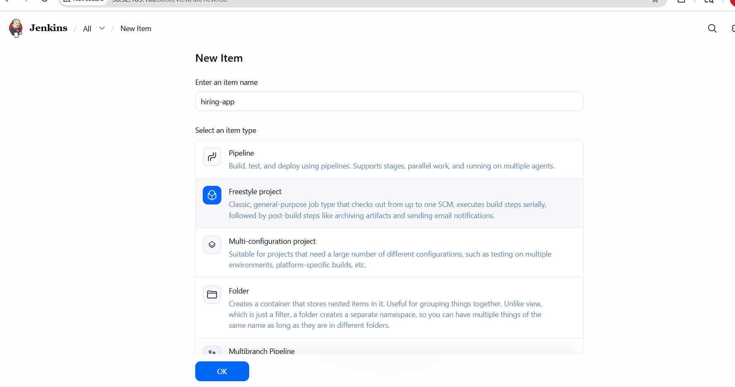
Choose git and provide url

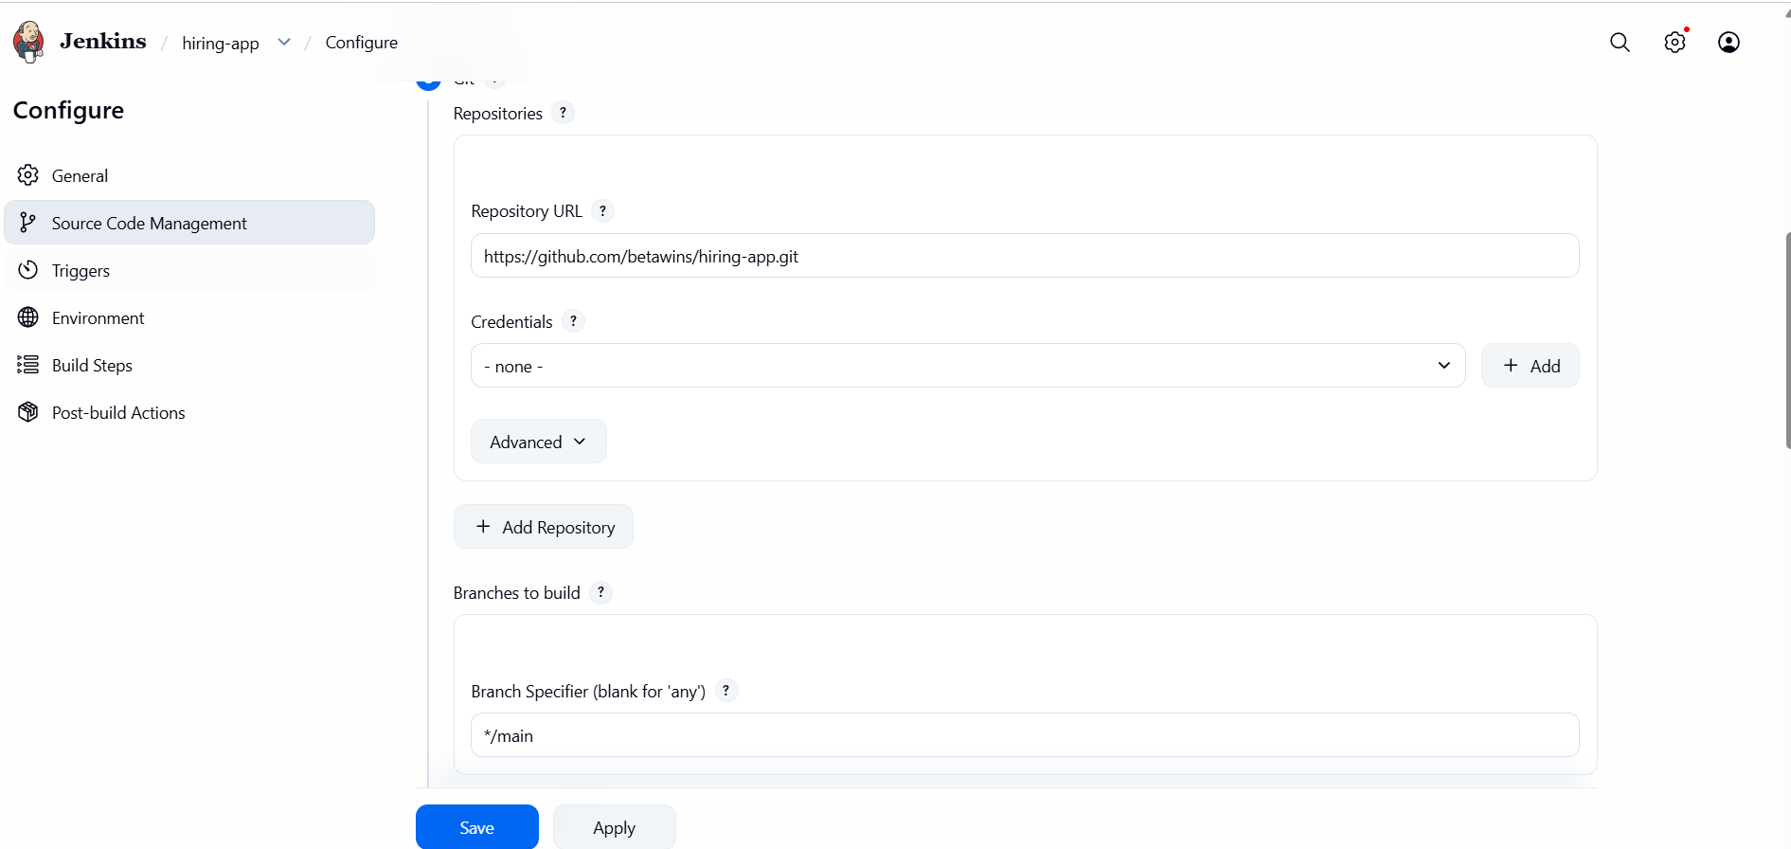
Click on add build step -- choose sonarqube scanner
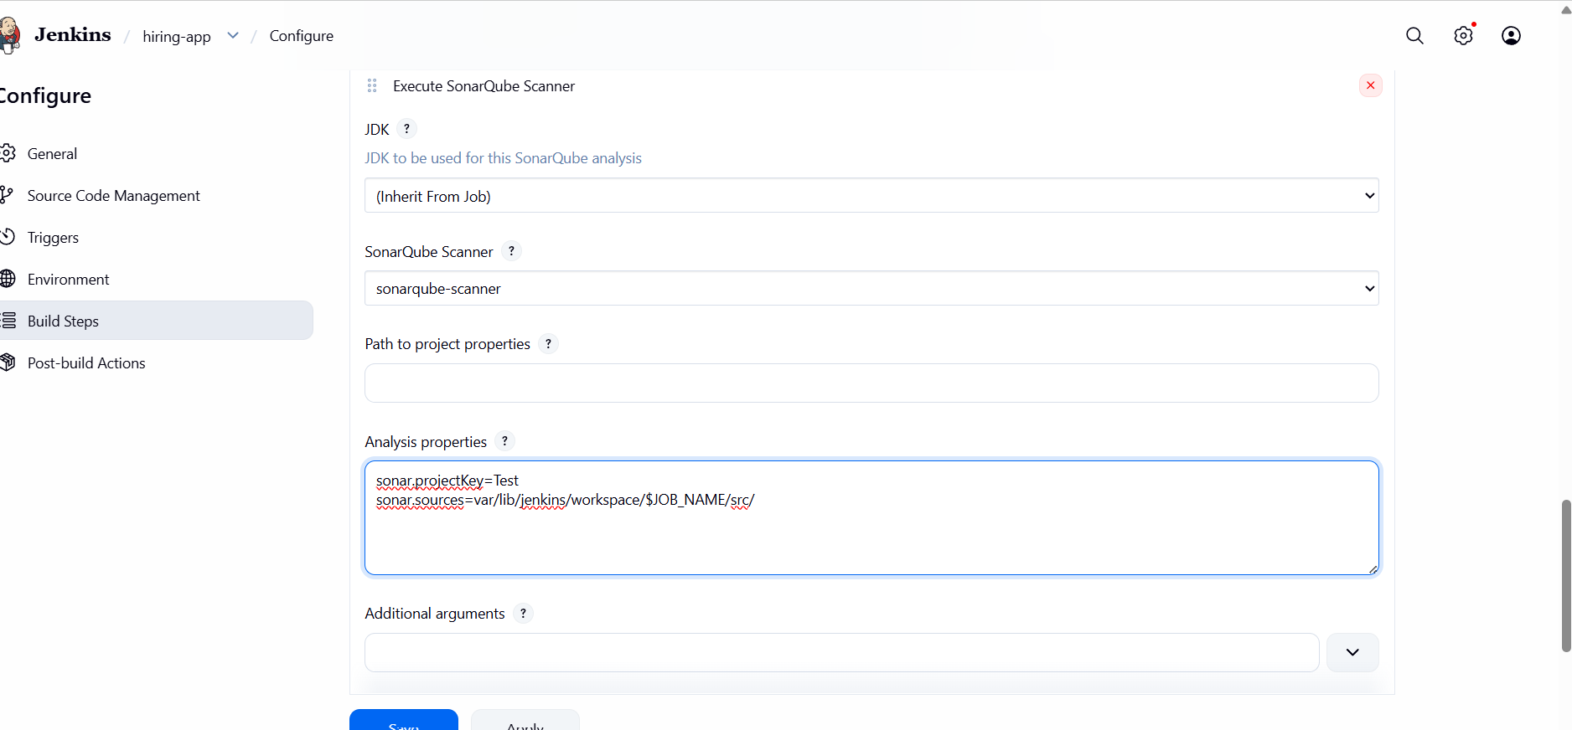
Go to post build actions -- choose slack notification
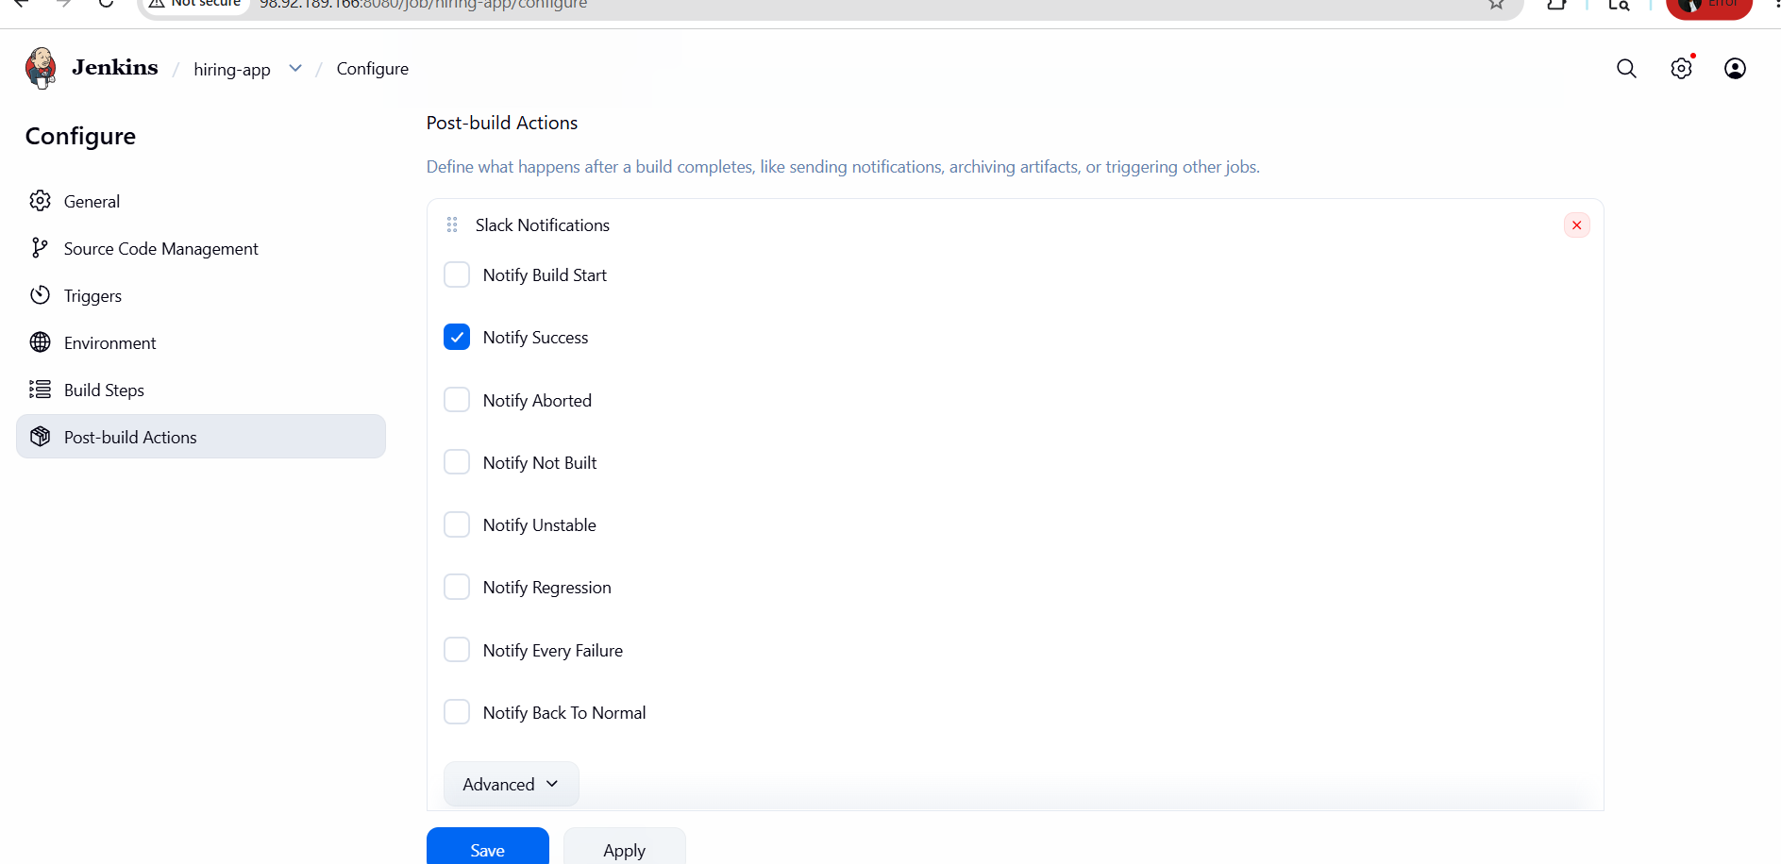
Provide workspace name --channel id -- click on test connection

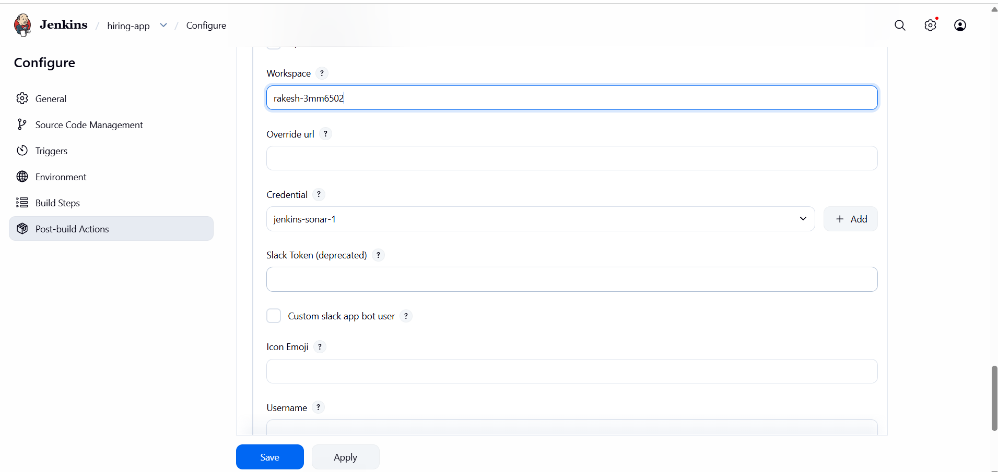

Click on build now
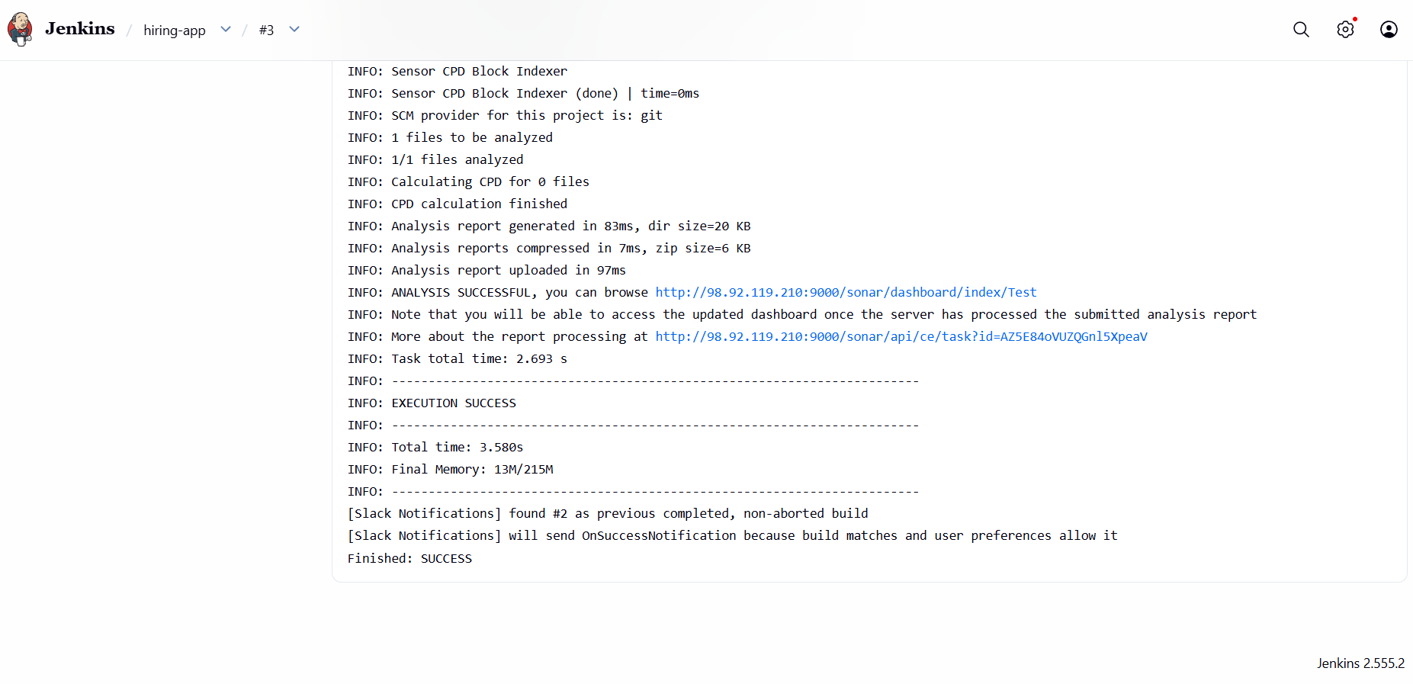
We are able to get the alerts
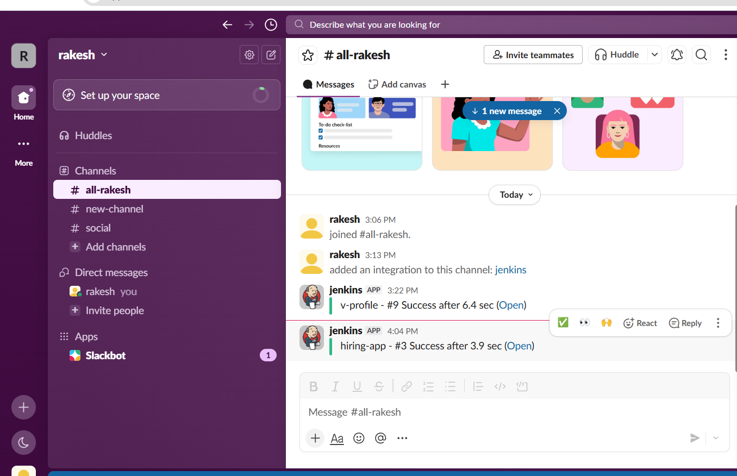

Also we can see the other project “TEST” is added in sonarqube
